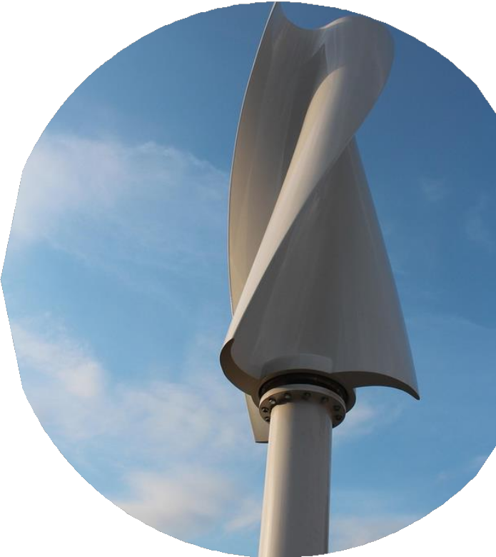






















Contents

Chapter 1 4
Introduction 5
Egypt Grand Challenges 6
Improve the use of alternative energies 6
Improve the scientific and technological environment for all 9
Address & reduce pollution in air, water, and soil 12
Reduce and adapt to the effects of climate change 16
Work to eradicate public health issues 20
Problem to be solved 23
Research 26
Other solutions already tried 29
Dogger Bank Wind Farm 29
Benban Solar Park 33
Aswan High Dam 36
Bieudron Hydro Power Plant 38
Chapter 2 42
Solution requirements 43
Design requirements 44
Selection of solution 46
Selection of prototype 48
Chapter 3 49
Materials and methods 50
Materials 50
Methods 50
Safety precaution 51
Test plan 52
Data Collection 52
Negative results 52
Positive results 53
Chapter 4 54
Analysis and discussion 55
Conclusions 57
Recommendations 58
Recommendations to Future Teams 59
Project’s benefits 59
Learning outcomes 60
List of sources in APA format 61

Chapter 1
Present and justify a problem and solution requirements

Introduction
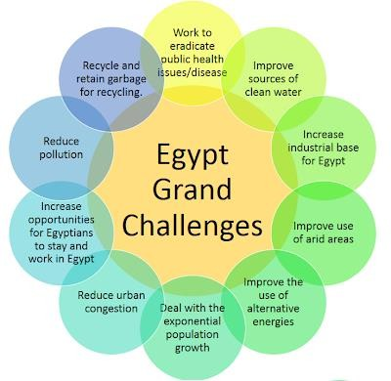
Egypt suffers from many economic, political, and industrial problems. 11 of these problems are the greatest and the hardest for Egypt to solve, which is why they’re Egypt’s 11 grand challenges as shown in Figure 1.
First, garbage and waste recycling. It’s a problem that drives Egypt to higher pollution rates. Second, urban congestion and its consequences. A problem that damages Egypt’s economy and resources. Third, public health issues. Many deaths and suffering happen in Egypt due to this problem. Fourth,

Figure 1 Egypt's grand challenges

reduction of industrial and agricultural areas. This problem is one of the reasons for Egypt's poor economy. Fifth, pollution fouls air, water, and soil. An environment destroyer problem that affects Egyptians’ health. Sixth, improving the use of arid areas. A problem that wastes much of Egypt’s land. Seventh, sources of clean water. Another problem that causes many diseases. Eighth, population growth. The biggest problem in Egypt is the cause of most of the grand challenges. Ninth, improving the scientific and technological environment. It’s a problem that affects the future of Egypt. Tenth, the effects of climate change. The problem that is considered the future cause of world end. Last, use of alternative energy. A problem that if solved, a better life awaits all people.

Egypt Grand Challenges

Improve the use of alternative energies

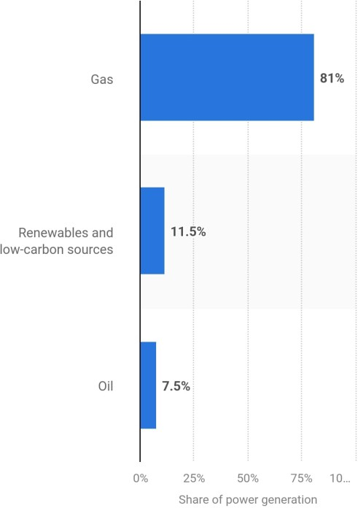
Egypt has several ways of generating electricity. Although Egypt still uses non-renewable sources of energy for main electricity generation. Most of Egypt’s energy comes from fossil fuels, consisting
of oil and gas. As illustrated in Figure 2, 81% of power generation in Egypt is from gas, 7.5% from oil, and 11.5% from renewable and low-carbon sources such as wind, solar, and hydropower.
Given that the consumption of energy in Egypt is 1540 kWh of electricity. And energy production in Egypt is around 3,850,000 TJ. The energy production from polluting sources is around 3,380,000 TJ, which is a massive problem as only the CO2 emissions are around 217.806 Megatons reaching 118% increase from 2000 to 2022,

and 0.6% of the global emissions according to IEA.
Figure 2: Energy sources in Egypt

These numbers are frightening as they risk Egypt with many health issues, high increases in petrol and gas prices, and global warming, which are concerning problems for all classes of people.

Causes:

Abundance of fossil fuel reserves.
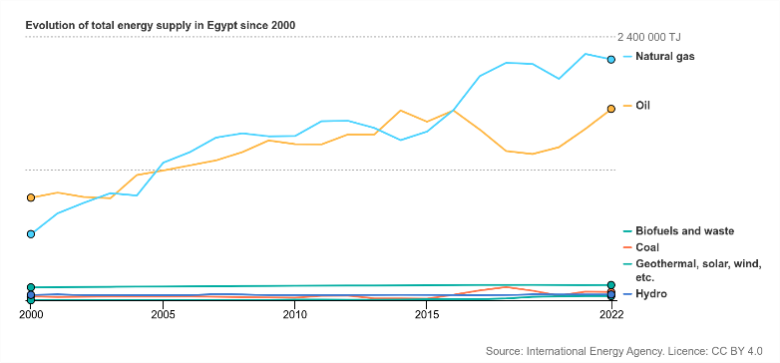
Egypt has many significant reserves of fossil fuels like oil and natural gas, especially in the Mediterranean and the western desert. Egypt ranks 26th with 4,400,000,000 barrels in 2016 with 0.27% of the world’s share
Figure 3

of oil reserves, making fossil fuels easily accessible. Egypt has historically invested in fossil fuel extraction, considering the 3.3 billion barrels of oil and the
77.2 trillion cubic feet (tcf) of natural gas at the end of 2018. As shown in Figure
3 Which makes replacement hard and costly.

- Industrial and transportation dependence.
Egypt's industries and transportation depend on non-renewable energy sources, making switching challenging. In 2021, the industries consumed around 611,094 terajoules of energy, accounting for 24.5% of Egypt's total final energy consumption. Transportation was responsible for 30.8% of the total energy consumption in 2021 according to IEA. In the year 2020/2021, transportation alone consumed about 12.23 megatons of petroleum products and natural gas according to Statista. This reliance on oil and gas is due to the existing infrastructure and technologies tailored for fossil fuels. Switching to renewable energy would require significant investments in new technologies, infrastructure, and workforce retraining, posing economic challenges.

Slow development of renewable energy
Egypt's switch to renewable energy has been gradual, with several factors contributing to its slow development. As of 2023, renewable sources accounted for 12% of Egypt's electricity generation, below the average of 39% according to ember-energy. The country's goal to achieve 42% renewable energy in its electricity mix by 2030 faces challenges such as financial constraints, outdated infrastructure, and regulatory barriers. For instance, the existing electrical grid requires many improvements to handle large-scale renewable projects. Additionally, Egypt's reliance on natural gas, which constituted 88% of its electricity production in 2023, has slowed the shift toward renewables according to the Atlantic Council. Despite these challenges, Egypt aims to accelerate the adoption of renewable energy in the coming years.

Impacts:

Air Pollution and Climate Change.
The use of fossil fuels in Egypt releases huge amounts of pollutants, including sulfur dioxide (SO2) and nitrogen oxides (NO2), contributing to severe air pollution. In Cairo alone, air pollution is responsible for around 18,000 premature deaths annually, accounting for 16% of the city's total deaths. Moreover, Egypt's greenhouse gas emissions have increased from 134 million tons of CO2 in 1990 to 352 million tons in 2019, being a 0.73% share of global emissions. This increase contributes to global climate change, leading to rising temperatures and sea levels that threaten Egypt's coastal regions and the Nile Delta.

Water Contamination, Desertification, and Land Degradation.
The extraction and use of fossil fuels have led to water contamination and land degradation in Egypt. Industrial discharges, including those from fossil fuel industries, have polluted the Nile River, affected water quality, and posed health risks. Additionally, Egypt faces many challenges with desertification and land degradation, with 96% of its land classified as desert. Random agricultural practices have exacerbated soil erosion, reducing available land for farming and threatening food security.

Economic Impact.
Egypt's dependence on fossil fuels has many economic impacts. The country has experienced a huge increase in greenhouse gas emissions, rising from
134 million tons of CO₂ equivalent in 1990 to 352 million tons in 2019, representing a 0.73% share of global emissions. This reliance on fossil fuels puts Egypt at risk of global energy market fluctuations and contributes to environmental degradation, which can affect sustainable economic growth. Switching to renewable energy sources could mitigate these economic vulnerabilities and promote a more resilient economy.

Improve the scientific and technological environment for all
Another important Egyptian grand challenge is the scientific and technological environment in Egypt. Science and technology are the keys to thriving; Thus, Egypt must improve the scientific and technological environment for all. The Ministry of Education said that Egypt ranked 79th in 2023, up from 83rd in 2020, in the Global Knowledge Index (GKI). Also, Egypt ranks poorly in education, scoring 49 out of 50 countries for grade 4 students in reading. And 34 out of 39 countries for grade 8 students. Additionally, its overall rank in the Human Development Index (HDI) is 97th globally, reflecting challenges in educational outcomes. Those statistics indicate a lack of Egyptian education. The illiteracy rate in Egypt decreased to 16.1%; however, it is still considered high compared to other countries.
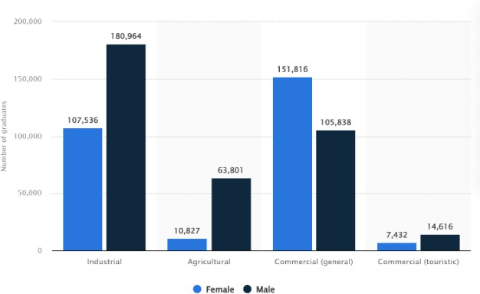
According to Statista, the number of technical and vocational education and training (TVET) graduates in Egypt as of 2021/2022 was around 640,000. Of these, 285,500 were specialized in industrial technical education, of which
62.7 percent were males, as shown in

Figure 4. Moreover, Egypt includes 10 technological universities. Compared to

Figure 4
The number of TEVT graduates in 2021/2022 year

a country like Germany, it has 17 technical universities, according to TU9. That indicates the lack of Egyptian technical education.

Causes:

Quality of Education
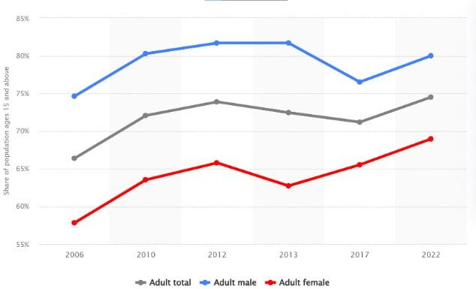
Later, the literacy rate in Egypt increased. However, as shown in Figure 5, it is still considered low compared to developed countries. There are some reasons for that low rate.
- Ancient curriculum: The curriculum in Egypt focuses on memorization more than critical thinking and problem- solving skills. It also depends on old concepts that are not beneficial nowadays.
Figure 5

- Private tutoring: According to ERF, on average, 40% of students receive private tutoring, and this percentage goes up to 60% for students at the secondary stage. 44% of students in urban areas take private tutoring, as opposed to 35 % in rural areas.

Governmental schools’ quality
Due to the high number of Egyptian governmental schools and the low quality, as shown in Figure 6, private schools in Egypt contain approximately 10.6% of the total student population, according to CIRA. The number of private school students in Egypt has increased by 6.3% in the last five years, much

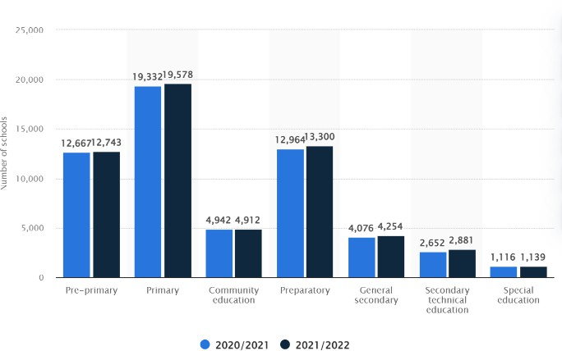

Figure 6

more than the number of
Number of schools in Egypt as of 2021/2022, by educational level

governmental school students, which increased by 3.6%.

Technological and Digital Divide

In Egypt, the curriculum focuses on teaching old technological concepts, such as Windows 7 and old programming languages that are not significant these days. Moreover, many students, especially in rural areas in Egypt, don’t have access to technology outside Egypt, which negatively affects the future of the country. Some programs try to improve Egyptians’ knowledge, like the Digital Egypt Cubs Initiative, which about 7090 students enrolled in in March 2023, according to DECI, but it is still not enough to achieve a thriving society.

Impacts:

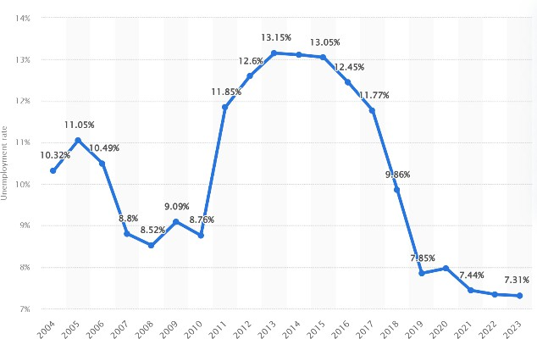
High unemployment rate
According to the technological advancement around the world, techno- logical jobs such as programmers and cyber analysists are required. And according to the digital divide in Egypt, not many people work in those fields.
Figure 7
Unemployment rate from 2004 to 2023 in Egypt

As shown in Figure 7, in 2023, the unemployment percentage in Egypt has reached 7.31% according to Statista. Which higher than the global unemployment percentage. As shown in Figure 8, the global unemployment percentage has reached 4.96% according to Statista.

National security risks
Egypt has weak cyber defence systems, which make banking, govern- ment, and infrastructure vulnerable to cyberattacks if there are not cyber- security workers to defend them. As of 2024, the internet penetration rate in Egypt reached 72.2 percent, up slightly from 37 percent in 2017, according to Statista, as shown in Figure 9.

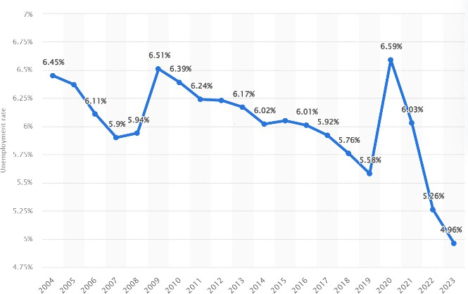
Figure 8
Global unemployment rate from 2004 to 2023

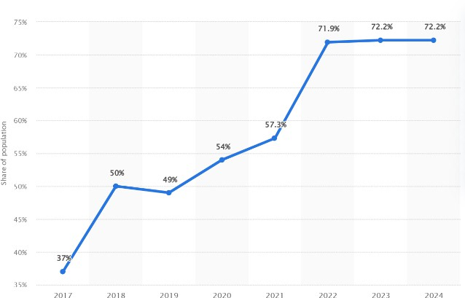
Figure 9
Internet user penetration in Egypt from 2017 to 2024

Additionally, cybersecurity threats rise as 90% of Egyptian companies face cyber risks (Egyptian Ministry of Communication, 2022).

Cultural and knowledge impacts
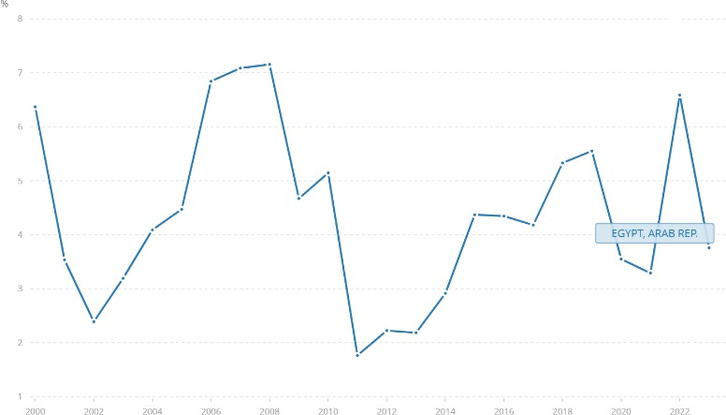
Only 30% of Egyptian students have access to digital learning tools and online websites, according to UNESCO in 2023. Additionally, research results in Egypt are low; therefore, Egypt ranks 86th among 132 economies in the Global Innovation Index 2023 according to WIP. Also, Egypt

Figure 10
GDP annual growth in Egypt

advanced to the 55th position in the global Research and Development (R&D) sub-index, according to the 2023 Global Innovation Index report according to academy of research and technology. Furthermore, Egypt’s GDP annual growth is shown in Figure 10.

Address & reduce pollution in air, water, and soil.
Egypt faces several grand challenges that affect its economy and people. Pollution, whether in the air, water, or soil, is one of these problems. Therefore, finding a solution to these problems is significant. For instance, air pollution in Cairo according to the Clean Air Fund, 33% of Cairo's PM2.5 air pollution concentrations result from road transport. The second type of pollution is soil pollution, which affects farming and, as a result, will affect the economy. , 79.24% of the Middle Nile Delta appeared to mely elevated levels of heavy metal contamination with average concentrations reaching 132 units. The third type is water pollution. It has several negative effects on the country and its people, according to UNICEF, approximately 7.3 million Egyptians lack access to safe drinking water, with 5.8 million residing in rural areas and 1.5 million in urban centers, and around 12% of the population living in dwellings not connected to the water system, compared to 4% in urban areas.

In 2019, Egypt was ranked 56th among 98 countries for pollution, according to IQAir. Therefore, the government should solve the water pollution problem and other types of pollution. Egypt generates about 16.4 billion cubic meters(BCM) of wastewater annually, comprising 4.4 BCM of sewage and 12 BCM of agricultural runoff. This wastewater should be exploited. Generating renewable energy will have a positive effect on the Egyptian environment instead of using fossil fuels as a source of energy, according to the Ministry of Electricity and Renewable Energy, 85% to 90% of Egypt's electricity is generated from fossil fuels such as oil and natural gas, this means most emissions of greenhouse gases come from the burning of fossil fuels.

Therefore, the Egyptian government should solve this problem by reducing emissions, specifically by producing renewable energy and addressing and reducing pollution, which requires a huge effort from people. Because a high percentage of people pollute the Egyptian environment, according to the Egyptian Environmental Affairs Agency EEAA, 10% to 15% of local pollutant levels are from the

Sources of energy in Egypt
Natrual gas
, 70%
Oil, 15%
Renewable sources, 8%
Hydroelectr ic, 7%
Figure 11: shows the percentage of sources of energy in Egypt.

open burning of waste. In the Egyptian countryside, many people are unaware of the impact of open-burning waste. Another crucial point is energy in Egypt, mostly generated by fossil fuels and a low percentage of renewable energy resources, as shown in Figure 11. The Egyptian government generates energy from renewable sources such as solar and wind at 8%, according to the International Energy Agency.

Causes:

Transport.
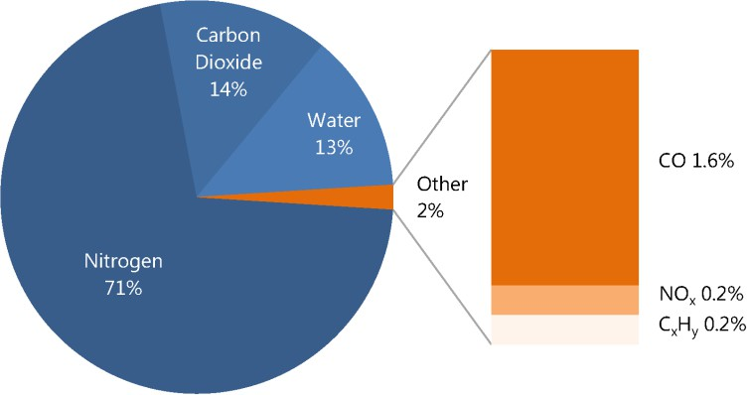
The main source of PM2.5 air pollution in the greater Cairo area is transportation, which accounts for 33% of the total, with an increasing percentage of private cars and taxis. This causes urban congestion problems at a percentage of 80%, and traffic volumes reach seven thousand 7000 vehicles per hour per lane, superior to the maximum theoretical flow of 1,900. This causes the emissions of greenhouse
gases, specifically carbon dioxide, at percentages from 10% to 15%. Car exhausts contain several toxic gases that can cause global warming and can affect the climate in Egypt and any country. It contains carbon

dioxide, CO2, carbon
Figure 12: shows the percentage of car exhausts.

monoxide, water vapor H2O, nitrogen oxides NOₓ, and unburned hydrocarbons HC. The percentage of these gases is shown in Figure 12. Carbon dioxide and water vapor are greenhouse gases at 14% and 13%, respectively. They cause air pollution in the world and Egypt by contributing to global warming.

Agricultural slash and burn
Agricultural slash and burn cause several problems, including reducing oxygen and increasing carbon dioxide. According to the Egyptian Environmental Affairs Agency, agricultural burning contributes 5% to 15% of total particulate matter PM emissions, particularly in rural and peri-urban areas such as those in the Nile Delta. So, this is another cause of air pollution. According to the Egyptian Environmental Affairs Agency EEAA, in the Nile Delta, where crop residue burning occurs, the percentage of local carbon monoxide concentration can increase by 10%-20% relative to baseline levels.

Throwing waste and industrial discharge into the Nile River
The Nile River is the main source of water in Egypt. People use the water from it for drinking and making food. Therefore, throwing the rubbish into the Nile River causes pollution in the Nile River's water. This waste management is a big trouble faced by the Egyptian government. According to the United Nations

Environment Programme UNEP, from 25% to 40% of municipal waste is either not collected or improperly managed. This uncollected waste is thrown into the Nile River and the local waterways. According to the Egyptian Environmental Affairs Agency EEAA, a significant percentage of industrial wastewater, estimated from 60% to 70%, is discharged into the Nile River without adequate treatment. This is because factories do not have the facilities to purify their wastewater. In many urban industrial areas, 80% of the wastewater is discharged without any treatment into the Nile River. This contributes to increased water pollution in Egypt and other countries along the Nile River.

Impacts:

Diseases and disorders caused by polluted water






According to the Egyptian Organization for Human Rights, approximately 38 million people drink polluted water, and the amount of untreated industrial pollutants that enter the water supply
3%
35%
50%
12%

Cairo Giza Qalyubia other cities
is estimated at 4.5 million tons per year. This can cause many diseases, such as cholera. According to the Egyptian Organization for Human, a significant percentage of poisoning cases are caused by pollution from different cities. 35% by Cairo, 12 %

by Giza, and 50% by Qalyubia. This
Figure 13: shows the pollution in different cities in Egypt

is shown in Figure 13. According to EEAA and other studies, approximately 100,000 people are diagnosed with cancer every year, and 15000 people get kidney failure. Also, there are other diseases attributed to water pollution in Egypt. From 10000 to 15000 hospitalizations annually, in dangerous areas where waterborne diseases, such as acute diarrhea, typhoid fever, and cholera.

Reduced Soil Fertility
According to the Egyptian Environmental Affairs Agency EEAA, heavy metal contamination stemming from industrial and municipal waste affects 15- 25% of cultivated areas in the Nile Delta. In these affected areas, the reduction in soil fertility has been linked to a decline in crop yields of around 10–15% for some staple crops. This also affected farming and, as a result, affected the economy because the Egyptian government and the farmers couldn't exploit the

agricultural land to plant the crops that need a high percentage of soil fertility. Soil salinity causes a reduction in soil fertility, but Soil salinity is caused by soil pollution. Salinization affects about 35% of Egypt's agricultural lands, particularly in the Lower Delta, limiting crop diversity to salt-resistant varieties like rice.

Temperature strikes.
Climate change occurs because of the temperature change, whether decreasing or increasing, by greenhouse gas emissions such as carbon dioxide and methane emissions. This not only causes climate change but also global warming. According to the International Energy Agency (IEA), Egypt’s energy sector was responsible for roughly 250 million tons of CO₂ emissions in 2018. Climate change harms crops by causing reduced water availability and lower rainfall. As a result, agricultural lands are experiencing desertification.

Reduce and adapt to the effects of climate change
Climate change is an environmental problem that negatively affects any country. The Egyptian improvement in the industry in the last years was one of the causes of climate change because fossil fuels are Egypt's main energy source. According to STATISTA, Egypt emitted approximately 250 million metric tons of CO_{2.} Thus, Egypt ranks second in Africa for CO₂ emissions. Climate change mainly occurs due to greenhouse gas emissions, especially CO_{₂.} Therefore, the Egyptian government makes efforts to produce energy from renewable resources. According to STATISTA, as of 2023, Egypt’s total renewable energy capacity reached 6,709 megawatts, making a 6.12% increase from the previous year. Other sectors in Egypt have a main role in increasing CO₂. According to STATISTA, the electricity sector was the largest producer of carbon dioxide emissions in Egypt, emitting nearly 77 million metric tons. The transport and manufacturing sectors followed, with 35.4 and 26.4 million metric tons of CO₂, respectively.

Also, the rate of change in temperature whether decreasing or increasing is one of the impacts of climate change. According to STATISTA, between 1901 and 2013, Egypt's average temperature increased by approximately 0.1°C per decade. This rate accelerated between 2000 and 2020, with a temperature increase averaging 0.38°C per decade, surpassing the global average of 0.31°C per decade. Also, according to Enterprise, in 2016, the energy sector was the largest contributor






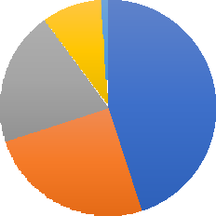

Figure 14
Sales
1%
9%
20%
45%
25%
Electricicyt and heat production
Transportation
Manufacturing and construction
Other fuel combustion and fugitive emission Bunker fuels

to Egypt’s total emissions of CO₂ _{by} 71.4 % within the sector; those fields are shown in Figure 14.
These greenhouse gas emissions contribute to climate change and global warming, both of which can cause trouble for any country, not Egypt only, for several reasons. Firstly, Egypt should generate energy from renewable sources to avoid the effects of non-renewable sources. Another important \]7nt point is that climate change not only harms the economy but also its effects on public health. According to the World Bank, in 2017, air pollution-related health issues were estimated to cost approximately 1.4% of Egypt's GDP. This air pollution is a result of climate change and other air pollution factors.

Causes:

Egyptian greenhouse gas emissions
Climate change mainly occurs because of greenhouse gas emissions. Whereby, Carbon dioxide and methane are excessively emitted into the atmosphere, hence acting as the leading driver of climate change. These gases trap the heat coming from the sun and, consequently, make the planet warmer. Although Egypt is not a major deforestation country, it might have experienced land-use changes that could have led to emissions. Climate change occurs due to greenhouse gases such as carbon dioxide, methane, and nitrogen dioxide, in Egypt, emissions of CO2 in 2015 were %73, methane %13, nitrous oxide %12, hydrofluorocarbons (HFCs) and perfluorocarbons (PFCs) about %1. This

compared to 2005 by %40, CO2 alone increased in ten years from %67 to 73. All these greenhouse gas emissions are increasing in Egypt, and this is causing significant damage, including climate change, and rising temperatures. These statistics are shown in Table 1.

Carbon dioxide | Methane | Nitrous oxide | HFCs and PECs
73% | 13% | 12% | 1%
Table 1, shows the percentages of greenhouse gas emissions in Egypt.

Using non-renewable energy sources.
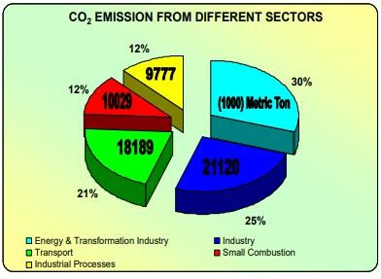
Most energy sources in Egypt are non- renewable because the Egyptian government depends on fossil fuels as a main energy source. Thus, these fossil fuels negatively impact Egypt, leading to climate change and global warming. According to Ember, Egypt generated 88% of its electricity by using fossil fuels in 2023, and the
per capita emissions are lower than the global Figure 15 Shows the CO2 emissions in Egypt.
average. Moreover, Egypt generated 12% of its electricity from clean sources. This is below the global average of 39%. To sum up, producing electricity from non-renewable energy sources harms the Egyptian climate. So, Egypt should generate electricity from renewable energy sources. Furthermore, Egypt's CO₂ is very high because of using fossil fuels as illustrated in Figure 15.

Deforestation and cutting down trees.
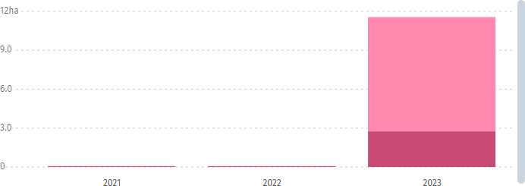
Trees and other plants absorb CO₂ and produce oxygen. Therefore, cutting them down reduces the plant's ability to regulate greenhouse gas emissions. According to Global Forest Watch, from 2021 to 2023 75% of tree cover loss in Egypt occurred within the natural forest and the total loss within the natural forest

was 9ah, equivalent to 471 tons of CO₂
Figure 16 a graph of cutting down trees in Egypt

emissions. Moreover, from 2001 to 2023, Egypt lost 1.82 kha of relative tree cover, comparable to a 1.2% decrease since 2000 and < 0.1% of all tree cover loss globally as shown in Figure 16. Therefore, the percentage of greenhouse gas emissions reaches a high level. Also, according to Global Forest Watch,

In Egypt from 2001 to 2023, 95% of tree cover loss occurred in areas where the dominant drivers of loss resulted in deforestation. To conclude, deforestation is the main cause of climate change in Egypt.

Impacts:

Economics and tourism
Climate change has a negative consequence on the economy because it disrupts tourism. Many people travel to Egypt because of climate change. When climate change happens, this will negatively affect the Egyptian climate. Therefore, Egypt will not be the most suitable country for tourism, because climate change is one of the most important factors in tourism. Moreover, climate change affects the coral reefs in the Red Sea. Coral reefs are fragile ecosystems, they are thought to be the most sensitive ecosystems to long-term climate change as they can only tolerate a narrow temperature range, and the sea surface temperatures are expected to increase by about 1-2C every year. So, this affects the coral reefs negatively and can destroy the coral reefs.

Extreme weather
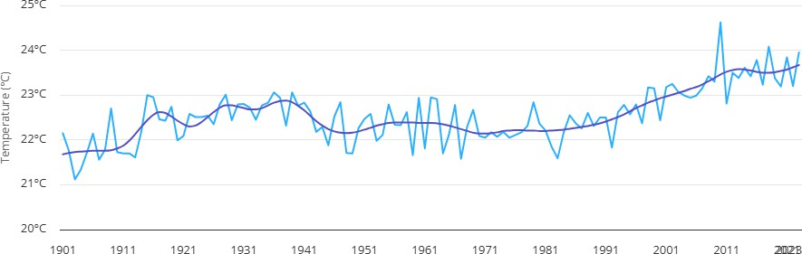
Climate change leads to changes in the temperature, and weather, increasing or decreasing the temperature. Temperature in Egypt is not constant because the climate change. So, the lifestyle of the people is affected by climate change. According to Reuters, in recent years, Egypt
has experienced record-breaking

temperatures. In July 2023, the
Figure 17: increasing in temperature from 1901 until 2011

southern city of Aswan recorded temperatures exceeding 49°C, while Cairo experienced highs up to 43°C. Therefore, this affects tourism in Cairo and Aswan. Also, this affects agricultural lands. The average temperature in Egypt in the last years is shown in Figure 17.

Human health
Climate change affects human health because the change in temperature leads to fever and other diseases indicated by the weather. Moreover, changes in

temperature lead to more cases of heat exhaustion and heatstroke. According to Health Development, In August 2015, a severe heatwave resulted in dozens of deaths due to heatstroke and over 500 hospitalizations for heat exhaustion. Therefore, the highest level of increasing temperature in Egypt leads to trouble in human health. Also, the decrease in temperature causes severe overstrain.

Work to eradicate public health issues
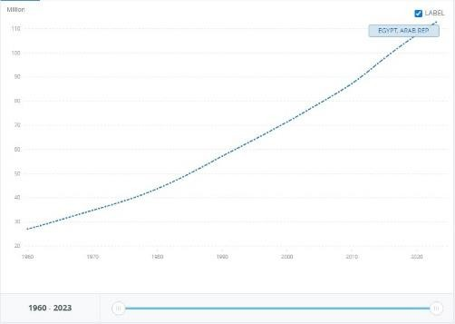
Infectious diseases are the world’s leading cause of morbidity and mortality. According to a report by the WHO at a global level, 7 of the 10 leading causes of death in 2021 were noncommunicable diseases, accounting for 38% of all deaths or 68% of the top 10 causes. The
vector-borne diseases are caused by pathogens

and parasites in human populations and account
Figure 18: population growth in Egypt

for more than 17% of all infectious diseases. Rapid population growth, such as in the case of Egypt, which has recently reached a population of 105,914,499 per capita in only 5% of the country’s surface area, as shown in Figure 18, multiplies the infection rates due to overcrowding and urban congestion. Behind these are factors like Poverty, Availability of health sectors, and personal hygiene. The impacts of these health issues are an economic burden and health sector overload, in addition to social and demographic changes.

Causes:

Low-Income
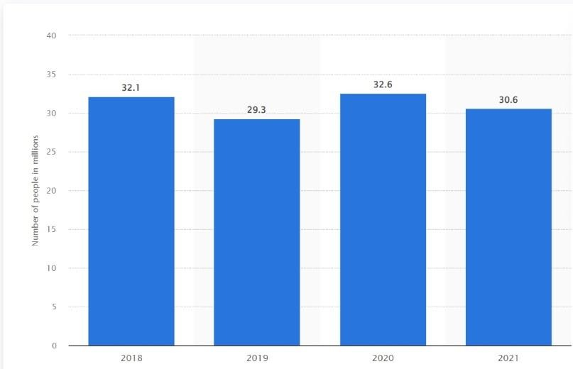
Income affects the public health sector; the leading cause of death for people living in a low-income country is communicable diseases, as 8 of the top 10 causes of death in 2021 in low-income countries were communicable diseases. Poverty affects access to
medicine and health services,
Figure 19
which affects a country with a
NO. of people living under the poverty line in Egypt from 2018 to 2021

poverty percentage of 30.6% as of 2021, as shown in Figure 19. Furthermore, chronic diseases due to genetic code are harder to fully eliminate and require genetic technology like Gene Therapy, which is limited and highly expensive; as of 2021, there were only 15 approved gene therapy products. Access to approved therapies remained limited in LMICs and is exclusively through managed access and compassionate programs.

Accessibility to public health.
Public health accessibility is another factor controlling the spread of infectious diseases. Egypt has the largest population in North Africa, with a population of 105,914,499 per capita as of 2024. This makes up 1.3% of the world’s population, congested along the Nile banks and delta,

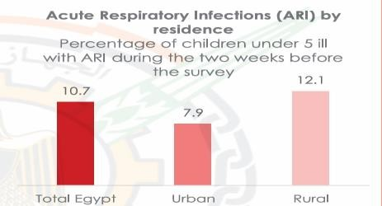
Figure 20
Acute Respiratory Infections (ARI) by residence

which only makes up 5% of Egypt’s surface area of approximately 1 million square kilometers. As a result, 95% of Egyptians live in 5% of the country. This urban congestion increases diseases, especially acute respiratory infections, as shown in Figure 20.

Personal Hygiene
In 2014, around 91 percent of the Egyptian population had access to water in their houses. However, a significant number of households are still not connected to the water system in rural areas and urban slums. 7.3 million people are deprived of access to safe water, among which 5.8 million live in rural areas and 1.5 million in urban areas. In rural areas, around 12 percent of the population lives in dwellings not connected to the water system, while in urban areas, 4 percent do not have a water connection. They are usually located in urban slums and poor settlements. Such individuals don’t have access to clean water needed for personal hygiene, which increases infections and public health issues.

Impacts:

Economic Burden
Health issues, disease outbreaks, and chronic diseases increase the burden on the healthcare spending of the state. Egypt’s health expenditure reached 4.61% of its GDP in 2021, reaching a maximum of 5.51% in 2001 and 5.31% in 2017, as shown in Figure 21. The government spending on health has reached this

percentage due to disease outbreaks and the increasing healthcare requirements due to the increasing population Egypt has a population growth rate of 1.7% (as of 2023) as shown in Figure 22 and the population went from 27M to 112M in 63years with 414% increase in population as shown in Figure 23. The increasing population ultimately caused healthcare prices to rise significantly, as shown in Figures 21 and 22. Disease outbreaks and health issues cause serious damage in highly populated and congested areas.
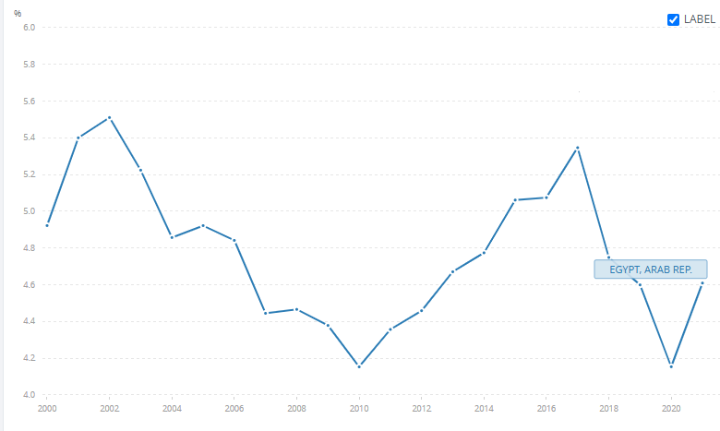
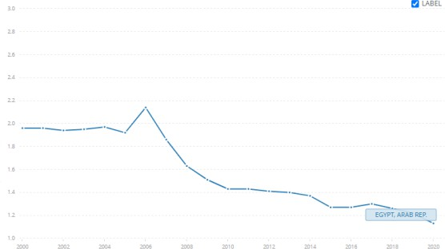

Figure 21: Egypt’s health expenditure in % of GDP, source: World Health Organization Global Health Expenditure database ( apps.who.int/nha/database )
Figure 22
Population growth (annual %) - Egypt, Arab Rep.

Overload on public health sectors
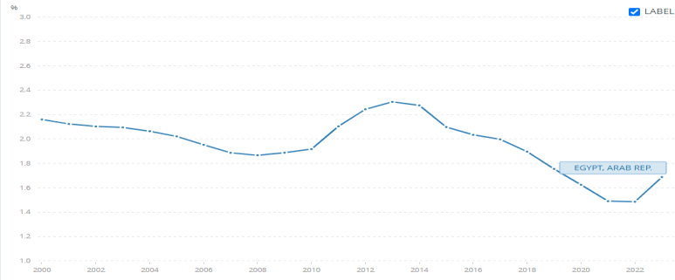
Overcrowding and population congestion have been an issue in Egypt since the mid-20th century. Egypt has
grown from 22 million in 1950 to 104 million in 2024. This resulted in multiple other problems, one of which was an overload of public health services. Public health services in Egypt can be divided into public
hospitals, vaccination programs, and Figure 23: Hospital beds (per 1,000 people) - Egypt, Arab Rep.
local medical centers. These public services are overloaded and cannot provide support for all individuals due to urban congestion and population growth. This can be seen, for example, in the Cairo Metropolitan Area, which has a population density of 40,000 people per square kilometer: up to 100,000/sq km in older districts and a population of 20 million people, which makes up 20% of Egypt’s total population. This area has 0∙23 health facilities per 10000 population and 1.4 governmental hospital beds per 1000 people as of 2014, as shown in Figure 23. This high population density, insufficient number of healthcare centers, and number of hospital beds ultimately lead to overloading the public health sectors.

Social and demographic changes
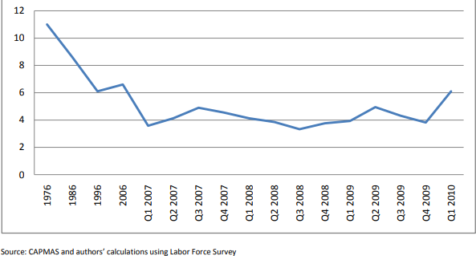
Disease outbreaks in rural areas of Egypt, where there is a lack of government and health services,

Figure 24: Internal migration rate in Egypt
encourage the rural population to move to the cities to escape the disease outbreak and utilize the more abundant healthcare infrastructure in the city. As a result, in addition to other factors like lack of services and lack of
job opportunities, internal migration reached 4% between 2007 and 2009 and increased to 6.1% in Q1 2010, which can be seen in Figure 24. This leads to more pressure and overload on the healthcare system there and leads to more disease outbreaks across the country.

Problem to be solved
Reducing Power Shortage Through Alternative Energy

Non-renewable energy sources, being the backbone of Egypt’s industrial sector, are an expensive, inefficient, and limited source of energy. As of 2021, 94% of Egypt’s energy supply is considered to be non- renewable 2021, with gas at 54% and oil at 38%, as shown in Figure 25.

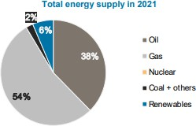

Figure 25: Egypt's total energy supply in 2021

With 1,066,747 (TJ) imports and 871,586 (TJ) exports, Egypt has a net energy trade of -195,161 (TJ), which increases energy costs in Egypt, increasing the prices for Egyptian consumers and reducing the net amount of distributed energy due to the cost of importing or producing energy.
The heavy load on the economy due to the increasing energy requirements is also due to the prices of imported non-renewable resources like oil, which has an average price of $76.48/bbl. Natural gas has an average price of
$5.75/MMBtu, which increases pressure on the national income. Furthermore,

this energy storage leads to an unfair distribution of electricity across cities; this can be seen in Nouba, South Sinai, which is located among tourist hotels, villages, and restaurants that get the majority of electricity and most infrastructure maintenance.
The power shortage issue in Nouba is caused by several factors, which are low- quality electricity infrastructure, high prices of non-renewable energy, and bad utilisation of renewable energy

Positive Consequences

Lower Oil Prices
Egypt has a power score of 1.82, which puts it at rank 65 in the Emerging Markets power ranking. In comparison to 2023, Egypt has dropped in the power rankings by 25 places, from rank 40 to rank 6. This drop in ranks is due to dependence on non-renewable sources such as fossil fuels. The price increases

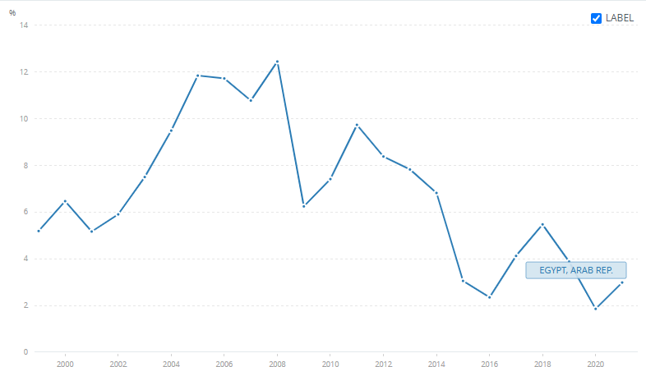

Figure 26: oil rent in Egypt

rapidly; for example, Oil rents are the difference between the value of crude oil production and the costs of producing it. Oil rent has increased to 3 in Egypt in 2021, as shown in Figure 26.

The high demand for fossil fuels such as oil and natural gas combined with the low supply of said fossil fuel has increased the prices of fossil fuels, thus increasing the load on Industry and Military sectors which require large amounts of fossil fuels.

Utilizing renewable energy resources such as wind energy, solar energy, and hydropower would decrease the residential demand for fossil fuels, largely decreasing the demand for fossil fuels and thus decreasing the fossil fuel price for all public sectors.

Reduced Electricity Prices
The current dependence on non-renewable energy sources in Egypt, like oil and natural gas, has caused electricity prices to increase. For example, reports

announced in January 2024 have shown an increase ranging between 10 and 40 per cent for different brackets, with the highest shouldering the largest hike in Q1 2024.
The rate for the first bracket, covering consumers of between 0 and 50 kWh, has increased from LE0.58 to LE0.68 per kWh.
The second tier, covering consumption from 51 to 100 kWh, is now LE0.78 per kWh, up from LE0.68. For the third bracket, when consumption exceeds 100 kWh and reaches up to 200 kWh, the rate rises from LE0.83 to LE0.95.
Consumption surpassing 200 kWh falls into the fourth bracket, which goes up to 350 kWh, with an increase from LE1.25 to LE1.55 per kWh. This pattern of price increase also continues on higher consumption, according to the report.

Utilizing renewable energy, such as wind energy, can solve such problems by increasing the local production of electricity, which would lead Egypt to have a power surplus instead of a deficit.

Less Pollution
Fossil fuel power generators are major pollutants to the air. The air contains three major pollutants that are harmful to the environment: carbon monoxide, nitrogen dioxide, and carbon dioxide. Fossil fuel plants and industrial sectors are the main producers of said gases. Furthermore, car emissions contribute to 33% of the air pollution in Egypt, this is because electric vehicles only make up 0.1% of car sales, therefore, 99.9% of cars in Egypt depend on fossil fuels, which not only increases air pollution but also increases oil prices.
As a result, Egypt is in the 12th position in the global pollution index and 9th in air pollution. Expanding the use of renewable energy sources would decrease the air pollution through reducing the importance of fossil fuel power generators and later fully replacing fossil fuels, thus reducing pollution while also reducing demand for fossil fuels.

Negative Consequences

Limited Industrial Capacity
Due to the high prices of fossil fuels, for example natural gas that has reached $5.75 per million British thermal units, combined with the price of moving such fuels across large areas of land to locations such as South Sinai, the cost of implementing industrial improvements in such areas is costly, and often

ignored despite the possibilities of said locations in areas of rock mining or other industrial sectors.
- Unfair Infrastructure Distribution
Fossil fuels require large power generators, usually around the center of the country or outskirts of central cities, and these generators require a large infrastructure, both underground and above the ground, to be transported to cities. The high cost of the required infrastructure can limit the reach of fossil fuel- generated electricity to certain main locations in Egypt.
As a result, electricity reaches in far locations such as South Sinai is limited, damaging the economy and social life.

Economic Loss
Egypt also has a large water supply through the Nile with an annual share of around 55 m3 billion. However, the water supply, fertile soil of 2.3 million ha, and industrial opportunities such as mineral extraction, building material extraction, food industries, and manufactures are not utilized to the fullest extent. This is because the energy required to fully exploit such resources is too expensive, making the process unprofitable. This reduces job opportunities and local income, ultimately causing economic loss in the country.

Research

Topics related to the problem

Air pollution in Egypt.
One of the main problems worldwide is the main cause for climate change, and it’s mainly caused in Egypt by generating power through fossil fuels and non- renewable sources, which is why researching it is important for identifying our problem.
When research has done on pollution in Egypt it’s found that Egypt is ranked the 9th in air pollution And Egypt holds the 12th position in the global pollution index, with a score of 82.7, making it one of the most polluted countries in the world. Cairo itself scores 95.8 out of 100, 10 times above the safe limits, being globally one of the most polluted cities in the world.

Electricity mix in Egypt.
Egypt has several ways of generating electricity. Although Egypt still uses non-renewable sources of energy for the main electricity generation. Most of Egypt’s energy comes from fossil fuels, consisting of oil and gas, and searching for how the share is distributed between the Energy sources is fundamental to finding the problem.
After research, it was found that 81% of power generation in Egypt is from gas, 7.5% from oil, and 11.5% from renewable and low-carbon sources such as wind, solar, and hydropower, where the consumption of energy in Egypt is 1540 kWh of electricity. Energy production in Egypt is around 3,850,000 TJ. The energy production from polluting sources is around 3,380,000 TJ, which is a massive problem as only the CO2 emissions are around 217.806 Megatons, reaching 118% increase from 2000 to 2022, and 0.6% of the global emissions according to IEA.

Power shortage in South Sinai.
One of the areas most affected by power outages in Egypt is South Sinai. Especially in the outskirted villages, which makes them the best places to consider and research in the process of deciding our problem.
After searching about the power shortage in South Sinai, it is found that there are Infrastructure Limitations as some areas within South Sinai have aging electrical infrastructure, which can lead to occasional faults and outages. As well as that, Regular maintenance and upgrades to the power grid can necessitate temporary shutdowns, affecting local communities and businesses. While there are Technical Issues. Unforeseen technical problems, such as equipment failures or grid imbalances, can cause sporadic power interruptions.

Topics related to the solution.

Alternative energy sources.
The exploration of alternative energy sources is important to solving power shortages in Egypt. By reducing dependence on fossil fuels. Researching this topic will contribute to economic growth, environmental preservation, and energy security, making it essential for solving our problem.

In Egypt, renewable energy sources accounted for only 11.5% of total electricity generation in 2023, while 77% was derived from natural gas. Solar and wind energy potential is vast, with an estimated 6.5 kWh/m² daily solar radiation and wind speeds reaching 10 m/s in certain regions. However, investment in renewables remains limited, with only $2.8 billion allocated in 2022. By increasing reliance on alternative energy, power shortages in Egypt can be mitigated.

Solar power generation.
The study of solar power generation should be made to reduce power shortages in Egypt. With increasing dependence on fossil fuels, Solar energy offers a sustainable and abundant source of electricity. Researching this topic is very important to choose the best possible solution.
Egypt has an average solar radiation of 6.5 kWh/m²/day, making it one of the most suitable countries for solar power generation. Despite this potential, solar energy contributed only 4.5% to Egypt’s electricity mix in 2023. The Benban Solar Park generates 1.8 GW. With power consumption exceeding 180 TWh in 2022 and peak summer shortages lasting up to five hours daily, expanding solar power generation is crucial for reducing electricity outages.

Wind power generation.
The study of wind power generation is important as a solution to Egypt’s power shortages. Wind energy provides a renewable, cost-effective, and sustainable solution. research and expansion of wind power will contribute to solving our problem.
Egypt has high wind energy potential, as wind speeds reach 10 m/s in areas like the Gulf of Suez. In 2023, wind power contributed only 3.7% to the national electricity mix, despite the country’s goal of reaching 42% renewable energy by 2035. The Zafarana and Gabal El-Zeit wind farms generate around 1.6 GW, but electricity demand exceeded 180 TWh in 2022, leading to summer outages. wind power is essential to mitigate energy shortages and make a stable electricity supply.

Other solutions already tried.

Dogger Bank Wind Farm
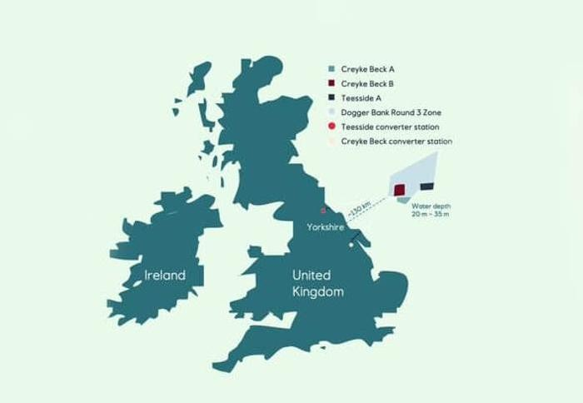
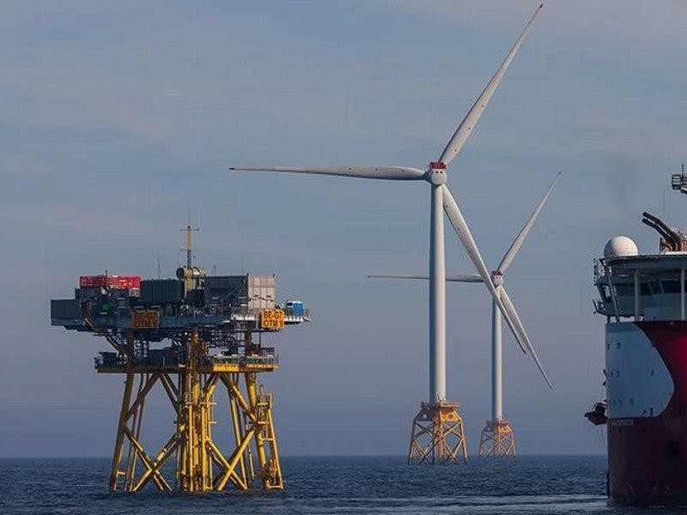
Dogger Bank Wind Farm is a facility built to generate electricity from the wind in the United Kingdom, as shown in Figure 27. It is divided into

Figure 27: Map of Dogger Bank Wind Farm
3 parts: Dogger Bank A with 95 wind turbines, Dogger Bank B with 95 wind turbines, and Dogger Bank C with 87 wind turbines. According to the Society of Operations Engineers (SOE), it was
Figure 24: shows the Dogger Bank Farm
built on the northeast coast of England. It is located in the North Sea approximately 70 nautical miles, and it stays away 130km off the coast of Yorkshire, as shown in Figure 27. It is an offshore wind farm using Horizontal wind turbines, specifically GE Haliade-X wind turbines. The construction of Dogger Bank Wind Farm started in 2020, It is a joint venture between three companies, which are SSE Renewables UK- 40% stake, Equinor Norway -40% stake, and Vårgrønn Norway- 20% stake. In 2026, it will generate electricity to power around 6 million UK homes. According to the Society of Operations Engineers (SOE), the height of the huge turbines in the Dogger Bank Wind Farm is 260 meters. This height can help increase the power output of the horizontal wind turbines. Dogger Bank Wind has a total capacity of 3.6 GW. Another important point is that the water depth in the Dogger Bank Wind Farm is from 20 m to 35m, making it suitable for fixed-bottom wind turbines. This depth is specifically in tranche B.

Mechanism
Firstly, the type of wind turbine is horizontal wind turbine, specifically GE Haliade-X, as shown in Figure 28. The Haliade-X has 3 massive blades. The blades are attached to a hub. The GE Haliade wind turbines use a direct-drive gearless system. The blades are connected to a permanent magnet generator. After

that, the generator converts the rotational kinetic energy into electrical energy. This is the generator system. The GE Haliade wind turbines don’t have a gearbox. It uses a direct- drive gearless system.
Secondly, the direct drive gearless system. Traditional

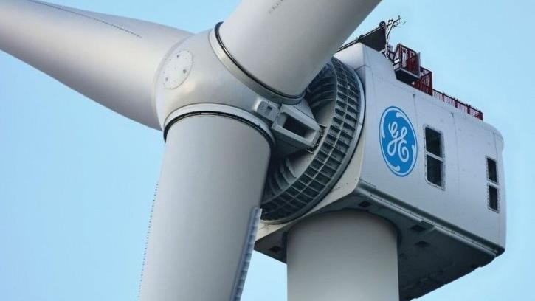
Figure 28: A picture of Haliade wind turbine

wind turbines use a gearbox to increase the rotational speed before sending it to the generator. The direct drive skips this step by connecting the rotor directly to the generator, making the process more efficient. It works in four phases. The first phase is rotating the blades by the wind. The height of the blades in the Dogger Bank Wind Turbines is 107 meters. Therefore, they capture the wind efficiently and begin rotating. The rotors rotate slowly, typically at 5–12 revolutions per minute. The second phase is turning the generator directly with the rotors. Instead of passing through a gearbox, the main axis is directly connected to a permanent magnet generator. This generator revolves at the same speed as the rotor. The third phase is generating electricity by the permanent magnet generator. It uses rare-earth magnets to generate a magnetic field. As the rotor moves, the magnetic field interacts with the copper coils inside the generator, creating an electric current. In the end, this process effectively converts mechanical energy to electrical energy. The last phase for distribution in the United Kingdom is stepping up the voltage for transmission of the electricity. Electricity is initially generated at a low voltage. So, the voltage needs to be increased for efficient transmission.
Finally, the electricity is translated by the high-voltage direct current cables. Then the electricity is transported by those cables 130 km to the UK mainland where it is distributed to the homes and companies. This is a mechanism for generating electricity by the GE Halaide-X turbines.

Points of strength

Direct drive (gearless) system in the Haliade wind turbines.
This system does not use a gear system. So, it reduces maintenance costs and mechanical wear. And allows for high efficiency. The gearbox in the wind turbines causes traditional issues, which are high maintenance costs and high mechanical wear. Also, the direct drive system uses a permanent magnetic

generator that directly converts the mechanical energy to electrical energy. This provides lower energy loss and high efficiency. Also, the design of the direct drive system provides more reliability and efficiency. Another important point is that the gear system produces noise and vibrations. On the other hand, the direct drive system is smoother and quieter. Also, the direct drive system is perfect for offshore environments, particularly in the North Sea where the Dogger Bank Wind Farm was built, because it produces low maintenance costs and the maintenance in offshore environments is difficult and expensive. And fewer moving parts in the direct drive system means less stress and lower failure rates.

High power output from Haliade wind turbines.
The Haliade wind turbines generate up to 14 MW for each one, with some variants reaching 13 MW in the Dogger Bank Wind Farm. Therefore, they produce a significant amount of energy that can be enough for 6 million houses in the United Kingdom, whereby each turbine can generate enough energy for 16000 British houses. This contributes to a total wind farm capacity of 3.6 GW, providing 5% of the UK’s electricity demand. Their high power output is due to a collection of advanced designs, large sizes, and modern technology.

Large rotor and blades for maximum wind capture.
The large diameter of the rotor blades helps capture more wind energy. The rotor diameter of each rotor on the Dogger Bank Farm is 220m. Therefore, it is the largest offshore wind turbine in the world. Also, the blade length is 107 meters, which allows for efficient energy production even at low wind speeds. The swept area is 38,000 m². So, this is a large swept area that increases the turbine’s ability to harness wind energy. The swept area is important because the amount of energy captured depends on the swept area. Also, large rotor blades help increase the power output of the wind turbines. Also, the turbine with big rotors can generate more electricity with fewer turbines. As a result, this reduces the cost and space demand for wind turbines.

Points of weakness.

Environmental and Marine Ecosystem Impact
The construction and operation of offshore wind farms can disrupt marine ecosystems by affecting fish populations and seabird migration patterns. Also, noise and vibrations from turbine installation, such as pile driving, can disturb marine mammals like whales and dolphins. The turbine and maintenance ship

increase human activity in remote ocean areas, which may affect fishing industries and local marine biodiversity. Therefore, offshore wind turbines should be designed carefully to minimize environmental harm. Another important point is that the Dogger Bank area is a vital habitat for fish species, crabs, and other marine life, which may be disrupted or destroyed. Also, turbine foundations change the seabed conditions. This affects the feeding and breeding patterns of certain species. As a result, wind turbines in this area can cause damage to the marine environment.

Limited Operational Efficiency in Extreme Weather.
The Haliade wind turbines are designed for high efficiency, but they must shut down if the wind speed exceeds 25 m/s to prevent structural damage. So, this is the trouble, because the Dogger Bank region experiences stormy weather in the winter, which causes temporary shutdowns and reduces electricity production. Also, icing on the blades in extremely cold conditions reduces the aerodynamic efficiency and leads to power losses. Another important point is that exposure to saltwater leads to corrosion and may affect the performance of the turbine in the future. In the end, extreme weather is related to shutdowns and efficiency losses. This reduces the reliability of power generation.

Large Size Creates Logistical Challenges.
The turbine’s nacelle is massive, weighing over 600 tons, and the blades are 107 meters long, making transportation and installation logistically difficult. Only a few ports and vessels in the world are capable of handling turbines of this size, and the sheer scale of Haliade-X wind turbines limits where they can be installed, making distribution more complex and expensive. Therefore, the huge size of the horizontal wind turbines in the Dogger Bank Wind Farm can cause some problems that affect the cost and maintenance of the turbines.

Benban Solar Park
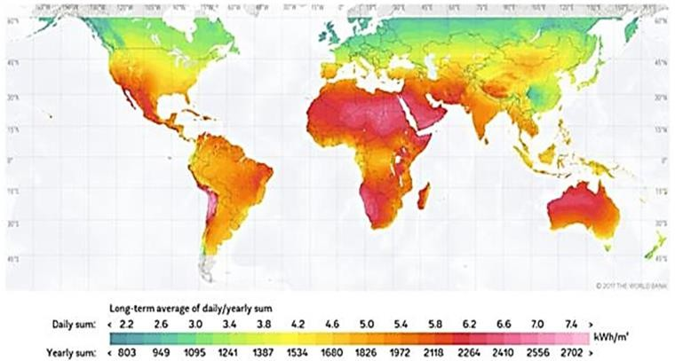
Egypt has established the largest solar power plant in the world in Benban village, Aswan. The Benban village is located in the western desert at a latitude of 24.26⁰ N and a longitude of 32.43⁰ E, 40 km north of Aswan and 650 km south of Cairo. The location of the Benban solar power plant is selected by the studies and reports by NASA and several international scientific institutions, which emphasize that the project site is one of the sun's brightest regions around the world. A satellite photo is shown in Figure 29. The Benban Solar Park is designed with a total capacity of 1600 MW covering an area of 37.2 square kilometers, and it is divided into 32 sub-systems. Egypt planned to extend the total capacity of Benban Solar Park to 2000 MW
from 40 sub-systems. The sub- systems are divided into four groups titled plant-1, 2, 3, and 4 and each plant consists of eight sub-systems with almost 50 MW AC. The four solar PV power plants are connected to
Figure 24

the Egyptian high-voltage
Figure 29: concentration of the daily sun.

network through four transformer stations titled Benban-1, Benban-2, Benban-3, and Benban-4. Benban Solar Park, as a part of the Egyptian Fit program, is the most immense national energy project in renewable resources.
Mechanism:
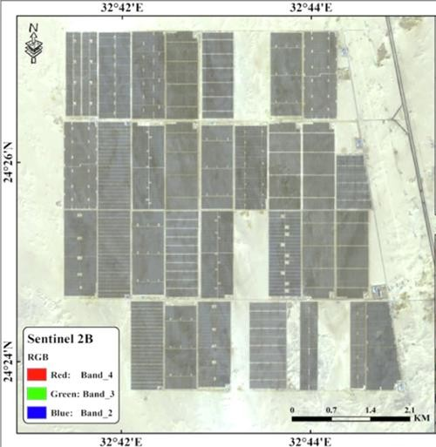
Egypt is geographically located between latitudes of 22⁰ N and 31.5⁰ N and longitudes of 24⁰ E and 37⁰ E, thus, it is situated in the central position of the global solar belt, as shown in Figure 30.
Figure 30
Each sub-system with a capacity of 50MW AC that is constructed on an area of 1600*600m2 is divided into
12 blocks; each one contains a number of trackers and two models of inverter, i.e., GrowattCP2000 Station-S and GrowattCP2520

Station-S. The main components for each 50MW AC sub-system are shown in

Figure 30.
The sub-system contains approximately 192,510 PV modules and 24 inverters to convert the direct current (DC)output of the solar photovoltaic modules into alternative current (AC) that is connected to the national grid electricity transmission system.
Figure 31 shows the schematic diagram of the tracker system in a 50MW sub- system that is divided into three strings, where each one contains 31 PV modules
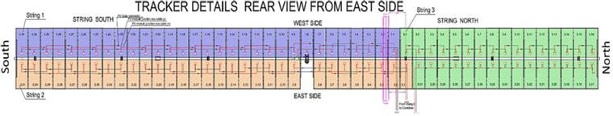
Figure 31: Rear view of trackers
connected in series. Then, the combiner collects the direct current and the voltage output from the strings. The designed inverters have specified features to
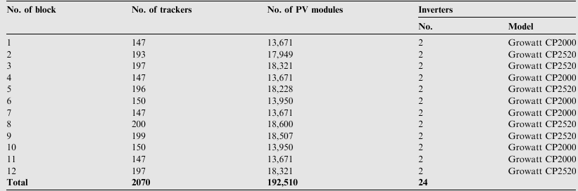
Figure 32 Components of the AC sub-systems.

maintain the required adaption to use in the Benban Solar Park such as automatic synchronization, high conversion efficiency, anti-islanding protection, and maximum power point tracker. In the present project, the power point tracker efficiency that is defined as the ratio between the ideal power supply to the inverter and the power converted by the inverter is maximized.

Points of strength:

Renewable Energy Contribution
Benban Solar Park generates 1.8 GW of clean energy, supporting Egypt’s goal of 42% renewable energy by 2035. The abundant solar radiation in Aswan it helps reduce dependence on fossil fuels and enhances energy security, positioning Egypt as a leader in solar energy in Africa and the Middle East.

Economic Benefits
The project attracted over $2 billion in investments, creating 10,000+ jobs during construction and supporting local businesses. It reduces reliance on expensive fossil fuel imports, stabilizes electricity costs, and strengthens Egypt’s role as an emerging renewable energy hub, fostering long-term economic growth and energy independence.

Environmental Impact
Benban Solar Park cuts CO₂ emissions by 2 million tons annually, reducing air pollution and combating climate change. By replacing fossil fuel- based power generation, it conserves natural resources and promotes sustainability, helping Egypt transition to a cleaner, greener energy system while preserving biodiversity.

Points of weakness:

Land Use Challenges
The 37 km² solar park occupies vast desert land, raising concerns about potential alternative uses such as agriculture or urban development.
Additionally, harsh desert conditions lead to dust accumulation on panels, requiring frequent maintenance and increasing operational costs, impacting long-term efficiency.

High Initial Costs
Despite long-term benefits, Benban required significant upfront investment for solar panels, inverters, and grid infrastructure. Heavy reliance on international funding poses risks for future expansions, while ongoing maintenance and technology upgrades add to the financial burden of sustaining large-scale solar energy production.

Grid Capacity and Transmission Limitations
Egypt’s electricity grid struggles with intermittent solar power, as Benban cannot generate energy at night. Lack of large-scale battery storage reduces reliability, and grid infrastructure needs upgrading to handle high solar output efficiently. Strengthening transmission networks is essential for maximizing renewable energy integration.

Aswan High Dam
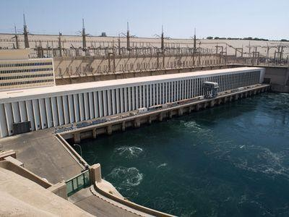
The Aswan Dam, shown in Figure 33, is built on the River Nile, just south of the city of Aswan in Egypt, and was completed in 1970.It is a rock-fill dam of 42 million cubic meters volume. The dam was constructed between 1960 and 1970. It aimed to increase the amount of hydroelectric power and regulate the flooding of the Nile, making it safer for agriculture around the Nile banks and

Figure 33: Aswan High Dam

increasing agricultural production. The Aswan High Dam is 3,830 meters long, 980 meters wide at the base, 40 meters wide at the crest (the top), and 111 meters tall. It contains 43 million cubic meters of material. At maximum, 11,000 cubic meters per second of water can pass through the dam. The reservoir, named Lake Nasser (named after Egypt's president at the time), is 550 km long and 35 km at its widest, with a surface area of 5,250 square kilometers. It holds 111 cubic kilometers of water. The bridge was constructed at a cost of about $1 billion. The Aswan High Dam captures floodwater during rainy seasons and releases the water during times of drought. The dam also generates 10 billion kilowatt-hours of electricity every year.

Mechanism
The Aswan High Dam generates electricity through a hydropower system. Firstly, the dam creates a large reservoir of water, in this case lake Nasser, then once the bridge starts generating electricity it releases the water into large tunnels called penstocks. The water flows downwards because of gravity and pressure increases as it travels through the penstocks. This high-pressure water then moves the turbine blades, causing the turbine to spin and rotate connected generators which generates electricity. After the electricity is generated, it is transmitted by

high voltage power lines to the power grid. The power plant at the Aswan Dam has a nominal capacity of 2,100 MW and is thus the largest power plant in Egypt. In 2015, the dam produced 5.68% of the Egyptian electricity supply and the production of electric power from the High Dam is 10 milliard kwh annually, which is double the amount generated in Egypt before the construction of the Dam.

Points of Strength

Increased Agricultural Production
Aswan High Dam has allowed farming to continue, even during drought years e.g. 1972 and 1973. This reduced the dependency on food imports. Furthermore, 3.4 million hectares have been irrigated by the Nile, which increased the agriculture output of Egypt

Flood Control
The High Dam limited the floods that hit the Nile Banks and ruined crop production in upper Egypt by blocking any incoming flood waves, it also saved lives in 1965, 1965, 1975 and 1987. Also, less flooding means that there are no flood repair costs, and insurance premiums are also cheaper.

Economic Benefits
The construction of the Aswan High Dam provided job opportunities to workers, engineers and construction companies used in constructing the dam. Furthermore, the maintenance of the Dam provided stable jobs for more Egyptian workers and The Dam itself has become an important tourist attraction along with the temples that line the river, which increases the overall income and economic benefit of this Dam.

Points of Weakness

Demographic Changes
Up to 100,000 Nubian (indigenous Egyptians) were forced to move from their ancestral homes. This damaged the Nubian Culture in Egypt and triggered multiple Nubian revolts to prevent the Dam from getting built.

International Conflicts
Currently Egypt and Sudan get 90% of the Nile's water. Other countries that the Nile flow through are unhappy and have asked for more. This could lead

to conflict, such as conflict between Egypt and Ethiopia and other countries along the Nile River.

Environmental Impacts
Fertilizers, chemicals and waste is no longer flushed away by the Nile's annual floods. This is because of the High Dam’s structure as it only allows passage of water. Furthermore, it is estimated that $100 million worth of artificial fertilizers have to be used every year to replace the nutrients (alluvium) trapped behind the dam. This obviously has an economic cost, but there is also the environmental cost of using chemicals and possibly the social cost of people consuming the chemicals.

Bieudron Hydro Power Plant

The Bieudron hydroelectric power plant, part of the Grande Dixence complex in the canton of Valais, Switzerland, is the country's largest and one of the world's most spectacular high-head plants, illustrated in Figure
34. Located near Conthey (46.183° N, 7.2515° E) at an elevation of approximately 2400 m in the Val des Dix valley, it is alongside the older Nendaz facility and makes use of the water
stored behind the 285 m high Grande Dixence

Figure 34, inside Bieudron plant, Switzerland


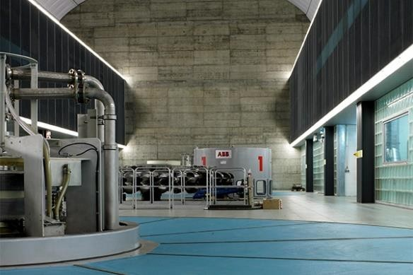
dam. With a nameplate capacity of 1269 MW from pelton turbines
Construction began in 1993 under the direction of Grande Dixence SA, with Andritz Hydro providing the Pelton sets and ABB the generators and transformers. Civil works comprised excavation of three main caverns—all exceeding 100 m in length, 39 m in height, and 25 m in width—and interconnecting tunnels requiring some 150000 m³ of rock removal. A 4.5 km headrace tunnel and an 8 km tailrace were bored through the Alps, together with access and ventilation drifts. Principal construction was completed in late 1998, and Bieudron commenced commercial operation in autumn 1998, with official inauguration early in 1999 at a cost of around CHF 600 million.
The prime justification for Bieudron was to optimize the exploitation of the 400 million m³ reservoir behind Grande Dixence, converting its enormous

potential energy into peak-load electricity to strengthen Switzerland's winter grid. By leveraging an outstanding hydraulic head within a compact underground footprint, the plant doubles the complex's output without inundating additional surface land. Its rapid start-up capability—reaching full nuclear-equivalent output in minutes—provides critical grid balancing and enables renewable integration across the Alps.

Mechanism
Biendron plant is an underground, high-head storage-scheme power station that makes use of the remarkable 1883 m head of water from the Grande Dixence reservoir to provide fast, peak load power by means of Pelton turbines. Water stored in the 400 million m³ Lac des Dix is emptied by a butterfly-valved intake into a 4.5 km headrace tunnel. This type of arrangement can permit operators to meter flow with excellent precision, coordinate generation with demand peaks without impinging on downstream river levels.
Inside the mountain, the flow enters a 70 m-tall, 12 m-diameter surge chamber that reduces pressure transients associated with fast valve movement. The flow is then conveyed through three parallel steel penstocks—each about 1 km long and fitted with 4.5m diameter spherical isolation valves—carrying up to 25 m³/s to each turbine. At the cavern inlet, a stainless-steel manifold distributes the flow into five fixed-geometry nozzles per turbine, accelerating the water to approximately 200 m/s. When these high-speed jets strike the spoon- shaped buckets at the rim of a 5.5 m-diameter Pelton wheel, their kinetic energy is transferred to the runner, generating rotation at 428.6 rpm.
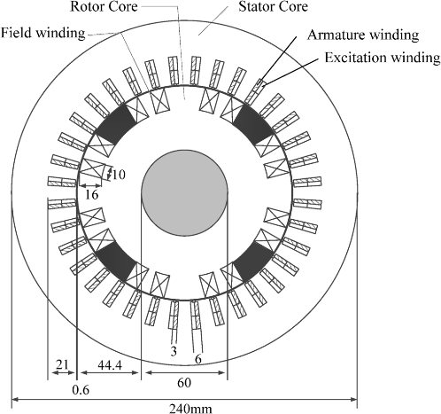
Each turbine's vertical drive shaft is mechanically connected to a 465 MVA synchronous generator with an approximate
weight of 800 t, shown in Figure 35. Stator and rotor are both fully water-cooled to manage the enormous thermal loads. The generators power the electricity out at 16 kV, which is transformed in a 28 m × 11 m transformer hall to 380 kV before being dispatched into Switzerland's national grid. Through the turbines, the water goes back down the Rhône valley via an 8 km tailrace tunnel, and the hydraulic cycle is finished.

Its whole cavern power measurement is 100 m by length, 39 m by height, and 25 m by
Figure 35, analysis of synchronous electrical generator

width—an excavated volume of approximately 90000m³—highlighting the scale of underground engineering required. Bieudron was designed for maximized Lac des Dix potential energy release at peak loads in minutes to deliver maximum
1.27 GW output. Its small, underground footprint delivers maximized minimized environmental footprint for significant grid stability while balancing variable renewables and hedging winter peak spikes with unmatched responsiveness.
With all these processes working behind the scenes by being flexible together, the hydro plant can generate capacity of 1269 MW and total over than
2.2 TWh annually generation, providing the whole Switzerland with electricity and critical grid balancing.
Positive Consequences

High-Tech Engineering and Record-Breaking Design
The Bieudron power plant is a hydroelectric engineering marvel with three world records: highest operating head (1,883 meters), most powerful Pelton turbines (423 MW each), and highest output per generator pole (35.7 MVA). Its three Andritz Hydro-designed turbines run at more than 92% efficiency, using a five-jet configuration to achieve maximum energy recovery from high-pressure water flows. The ability of the plant to rapidly deliver 1,269 MW onto the grid, comparable to a nuclear reactor, offers essential grid stability and flexibility, especially in balancing Europe’s intermittent alternative energy sources. The penstock breakage after 2000, reengineered infrastructure involved grouting and rerouting to offer additional durability, an instance of durability and ingenuity in hydroelectric technology.

Economic and Environmental Sustainability
As Switzerland's biggest hydroelectric station, Bieudron generates around 2,402 GWh annually and contributes considerably to the country's renewable energy targets in overcoming the reliance on nuclear power. With its addition to the Cleuson-Dixence Complex, it maximizes the utilization of water resources by the Grande Dixence Dam reservoir while reducing environmental impact via shared infrastructure. The plant allows Switzerland to serve as an energy exchange center for Europe, contributing to regional energy security and attracting investments from utilities like Alpiq and Axpo. In addition, its modernization (2005–2009) and ongoing modernization, including the 2024 spherical valve installation by Andritz, offer long-term cost savings and operating excellence in harmony with Switzerland's Energy Strategy 2050 towards sustainable development.

Negative Consequences

Geotechnical and Infrastructure Weaknesses:
The Bieudron power plant's pressurized penstock reliance and high- head configuration (1,883 m) involve inherent geotechnical risks. In December 2000, a catastrophic penstock rupture occurred due to dynamic stress fluctuations and unstable rock conditions, liberating over 150 m³/s of pressurized water. This devastated 100 hectares of land, resulted in the death of three people, and required a nine-year shutdown for redesign and remediation. The incident revealed vulnerabilities in geological assessment and material deterioration under extreme hydraulic stresses (203.2 bars). Post-accident modifications, including grouting and penstock rerouting, were very costly (~CHF 300 million) and operationally complex. Though implemented, the plant's use of vintage Alpine infrastructure poses long-term maintenance issues, particularly with climate change inducing permafrost thaw and rock instability in the Valais region.
- Economic and Regulatory Constraints:
The plant faces profitability challenges due to fluctuating electricity prices and steep production costs. Swiss hydropower companies pay a "water royalty" (up to 25% of production cost) to cantons for utilization of water, which boasts financial viability during periods of low wholesale market prices (~3–5 CHF cents/kWh). Additionally, stricter environmental regulation according to Switzerland's Water Protection Act demands more residual water flows in rivers, reducing the plant's annual generation capacity by ~2–5%. While Bieudron generates 2,402 GWh per year, such constraints limit revenue generation and deter new investments in modernization. Moreover, the plant's integration into the energy market of Europe is also impeded by Switzerland's non-membership in EU electrici- ty market coupling, which limits opportunities for monetizing its rapid respond capability (1,269 MW in minutes) for balancing grids.

Chapter 2
Generating and Defending a Solution

Solution requirements

Efficiency
Efficiency is one of the solution requirements of any successful solution. Efficiency means reaching the best possible results, leading to solving the problem successfully, regardless of the cost and the time needed for the process. For instance, Darrieus wind turbines have high efficiency, but they are the opposite of the Savonius wind turbines because Savonius works at low wind speeds and Darrieus wind turbines operate efficiently at high wind speeds, but they are a non-self-starting system, while Savonius wind turbines operate efficiently at low wind speeds with self-starting. Moreover, an effective project works well without disruptions for long-term shifts also, regardless of its cost, however minimizing cost makes the project efficient overall.

Eco-friendliness
Any successful project should be eco-friendly, because of several reasons. Firstly, reducing pollution, the eco-friendly project achieves this point, because it doesn’t use toxic substances in the process of generating energy or other products. Thus, it doesn't have negative consequences on the environment. For example, microbiological cells work with microorganisms, such as bacteria. This bacterium breaks down the organic matter; these organic matters typically are wastewater, human waste, and other organic matter. This process is eco-friendly and useful for the environment. Also, projects that use sustainable energy, such as solar panels, wind turbines, and hydropower stations are eco-friendly. Producing energy from these projects is better than producing energy from fossil fuels.

Availability
The materials of any project should be available at low costs. This is important for constructing the project in a short time. Furthermore, a project with expensive materials typically is not the first choice for solving the problems that governments and organizations face. For instance, building projects with expensive materials such as platinum and steel is not the first choice, many projects are better than this project, meaning searching for natural materials that are available in nature, or less expensive projects with less efficiency, but make the same work. This can be more available and reduce the costs of constructing the project. Moreover, most projects with less expensive materials give near results to the original project.

Cost-effectiveness
Project costs are one of the most important factors in achieving success. For example, a project with low costs that produces energy with moderate efficiency is better than a project with high costs that produces energy with high efficiency. This is called cost-effectiveness. The difference between a project with high costs and a project with low costs should be huge. Moreover, projects with high costs are available, and with more research, these projects can be developed by companies to be highly efficient. Also, efficiency depends on cost. Therefore, the definition of cost-effectiveness is providing projects and services at the lowest possible price without compromising quality.

Design requirements

Produce at least 40watt per second in at most 5 minutes
The project should generate 40 watts per second in at most 5 minutes or 40 joules. Also, Constructing the prototype by using the scientific method that produces 40 watts per second at most in 5 minutes is one of the design requirements. So, the scientific method is also important. Also, the generator should be constructed to generate 40 watts per second if the selected solution is the vertical wind turbine to generate electricity from wind energy. Also, the method of generating electricity should be efficient to generate 40 watts per second in the prototype.

The energy in any storage device is to be used at any time
After generating electricity, there should be a storage device to store the energy generated and use it at any time. This storage device can be a battery, thermal, or mechanical system. So, in the electrical circle, there should be a storage device connected to the generator or other methods of generating electricity. This storage device will store energy estimated at 40 watts per second, and this electrical energy will be stored for use at any time.

Using waste material in your construction
The using of waste material is preferable in the project because using waste material helps reduce environmental pollution. Also, this contributes to recycling these materials. Examples of waste materials are wastewater, plastic, glass, and metals.

The prototype should not exceed 5m³ in volume.
The volume of the prototype and its parts should not exceed 5m³ in volume. Volume is the amount of space occupied by any three-dimensional solid. Therefore, the space occupied by the prototype should not exceed .5m³ in volume. This means the volume, not the mass.

User friendly
The prototype should be user-friendly in other words, it should be not complex. Firstly, the mechanism of producing electricity. The mechanism should be simple and affordable to generate 40 watts per second. This means generating electricity of more than 40 watts per second is not preferable. Also, the parts of the prototype should be eco-friendly and safe. Another important point is that the prototype should be usable many times.

Environmentally friendly
Generating electricity should be environmentally friendly. In other words, using polluted materials is not acceptable. The materials in the prototype should be waste material, and these materials will be recycled. As a result, recycling will be environmentally friendly. Also, it is not acceptable to generate electricity by using fossil fuels. As a result, this will pollute the environment. To sum up, the method of generating energy should be clean and suitable for the environment.

Fast in producing energy
The prototype should generate electricity in at most 5 minutes. As a result, generating electricity should be fast. Another important point, the prototype should generate 40 watts per second at this period efficiently. As a result, the prototype should be fast in generating 40 joules of electricity efficiently. To sum up, fast in producing energy is one of the design requirements needed to the prototype with the efficiently.

Non-impediment
Non-impediment means your device will not negatively affect the student’s activity. This point is important for the community, the project should be quiet when it generates electricity, causing noise is not preferable. Also, the security system, while constructing the prototype, the students should follow the methods of security system.

Selection of solution

Location

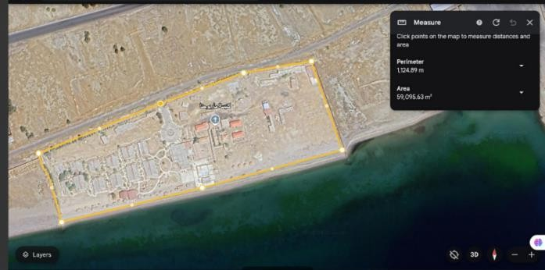
The selected solution is a helix wind turbine. The best conditions for the helix wind turbine are the low wind speed, moreover, it can work in omnidirectional wind. Therefore, this will solve the problem of low power shortage and reduce the use of non-
renewable energy sources in regions where there is omnidirectional wind and low wind speed. As a result, the helix wind turbine represents the most suitable solution for regions that have
these environmental conditions. One
Figure 36 The selected location for the selected solution.
of these regions is the Al Sayadeen
village in the south of Sinai in Nuweiba city. The wind speed there is from 3 to 6 meters per second, which is suitable for a helix wind turbine. Also, the direction of the wind speed is not constant, as shown in Figure 36. To solve the problem of power shortage in this location, the helix wind turbine is the selected solution. The helix wind turbine is constructed according to particular dimensions to generate electricity for the houses and factories in the Al-Sayadeen village. The helix wind turbine is constructed according to particular dimensions to generate electricity for the houses and factories in the Al-Sayadeen village.

Materials
The solution is to select the helix wind turbine. The materials needed to construct it in real life are divided according to the parts of the wind turbine. Firstly, the blades, the blades will be made from aluminum, because it is lightweight and durable, another essential point is cost-effectiveness. Secondly, the tower support structure (the vertical axis) will be made from steel because of its resistance to rust and efficiency. Also, using steel is more suitable for large turbines. Thirdly, the shaft and bearing will be stainless steel shafts for the same reasons as the tower support structure. The base and foundation will be made from concrete to provide more stability and less cost than steel and other materials. The generator will be a direct-drive gearless system, it consists of a permanent magnet generator. The direct drive system’s electrical components are voltage regulators that convert AC to DC and regulate the output voltage,

inverters, wiring, and connectors. The wiring and connectors will be made from high-quality copper for more efficiency. The shaft will be made from strong steel. Finally, these are the materials needed to construct the helix wind turbine in real life.

Mechanism

Drag-based vertical-axis wind turbines depend on the drag force. They are composed of two concave blades that make an S-shape. When the air comes into contact with the blades, the force on the concave blade is greater than it is on the convex one. The difference between the two forces is called the drag force. Because of the significant force on the concave blade, the turbine starts rotating on its convex side direction. The force on the convex blade makes a negative torque on the turbine. As it is less than the positive torque, it does not make the blade rotate in the other direction, but it reduces the speed. As a result, the power coefficient is reduced, too.
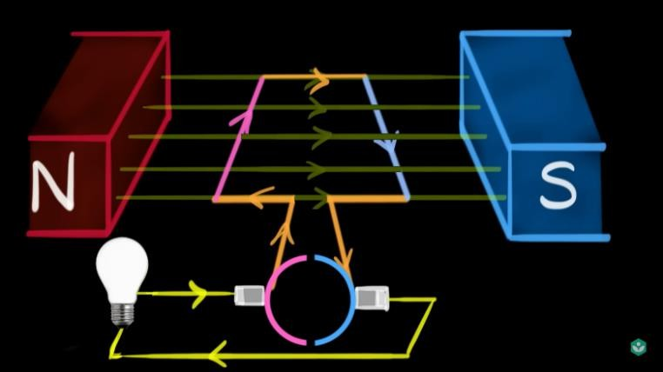
The two blades are connected to the main shaft. The project depends on a direct drive system. That means there are no gears to transfer the kinetic energy from the main shaft to the generator. So, the main shaft is connected directly to the

generator. It’s known that when a
Figure 37: Mechanism of generator

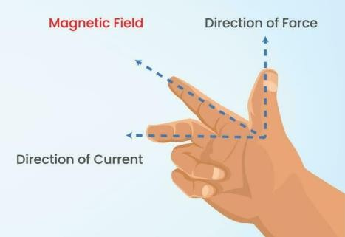
wire moves inside a magnetic field, electricity is produced because of the change in the magnetic flux, which
produces a potential difference, making a current. Therefore, if a coil of wire is made and starts rotating, there will be a current through the wire. We can use the right-hand rule to simplify the process, as shown in Figure 38. When the rotor rotates, the coil
rotates, creating a potential Figure 38: Right hand rule
difference to produce a current. As shown in Figure 37, the commutator is

divided into two pieces. That’s why the current direction produced by the generator is one-directional DC. In the alternator, every side of the coil is connected to a commutator, which changes the direction of the current, creating an AC. Finally, the goal of that process is to create a change in the magnetic flux to create a potential difference and produce an electric current from the kinetic energy.
The electricity coming from the generator after this process goes to a rechargeable battery to store the electric energy as chemical energy, allowing us to use the energy at any time.

Selection of prototype

Materials
To visualize the prototype, a 3D design is made accurately for the prototype. The 3D design is illustrated in the following figure. The materials are chosen based on certain criteria. Malleability is the ability of a material to be compressed into thin sheets without breaking. It’s important as the blades are supposed to be as thin as possible. Elasticity is the ability of a material to be pulled or compressed without breaking. It is important since the blades need to be curved to catch the wind. Density is the property that determines the mass of a certain volume of the material. It’s important because in order for the prototype to rotate due to wind, it needs to be big as well as light; therefore, a low-density material is required. Based on those criteria, Aluminum plates were chosen for the blades. That’s because they are the second most malleable element after gold. And it's elastic enough to be curved as needed. The shaft is a poly pipe as it’s rigid enough while also being very light. A direct drive electricity generation system is chosen for its efficiency. It’s composed of two magnets, a steel shaft, and wires. It works over the change in the magnetic flux due to the shaft rotation.

Dimensions
Precise dimensions are determined based on the desired output of 22.5 W/S. the blade’s height is 0.8 m. The blade’s width is 0.22 m. The chord length of the blade is 19.1 cm. The height of the shaft is 0.8 m. The diameter of the shaft is 1.5 cm. The minimum radius is 4 cm.

Chapter 3
Constructing and testing a prototype

Materials and methods

Materials
Table 2: Materials have been used
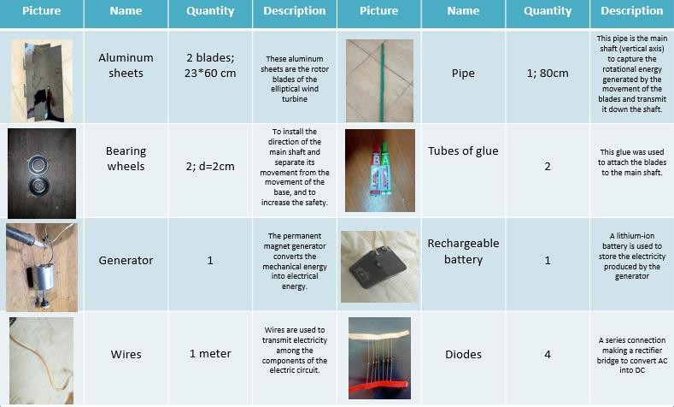

Methods
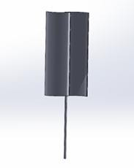
- A 3D design was made to illustrate the prototype’s main shape and dimensions, as shown in Figure 39.

- The rotor blades: The first step in constructing the prototype is to make the rotor blades. The blades were made by cutting the aluminum sheets into 2 sheets, 23cm wide, and 60 cm long, as shown in Figure 40. Then, the concavity in these sheets was made to capture the energy. Then the rotor blades were connected to the main shaft by using a tube of glue. There were 2 blades in the prototype of the elliptical wind turbine.

- Main shaft: During the construction of the rotor blades, the main shaft was prepared using a pipe, as illustrated in Table 2. The length of the main

Figure 39: The 3d design of the rotor blades and the main shaft.
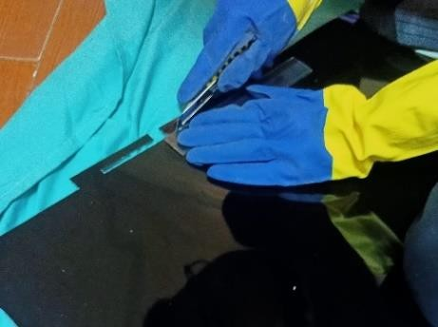
Figure 40: Cutting the blades

shaft is 80 cm. The main shaft was made to transfer the mechanical energy from the elliptical motion of the blades to the generator. Moreover, it supports the moving parts. After making the main shaft, the blades were connected to it as shown in Figure 41.

- After making the moving parts, the bearing wheels were placed, as shown in Figure 42, to ensure a constant direction for the main shaft and separate its movement from the movement of the base, and to increase the safety.

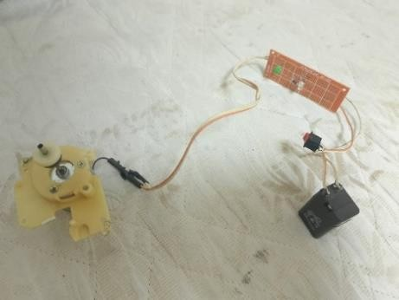
- The most critical step is making the generator and installing its components. The generator was connected to the main shaft to convert the mechanical energy made by the rotation of the blwades into electrical energy. Then the electricity produced by the generator will be stored in the rechargeable battery. During the transfer of electricity from the wires to the battery. There is a rectifier bridge that converts AC into
DC. Also, there is a rectifier diode that makes the electric current flow in one direction only to the battery. All these steps are shown in Figure 43.

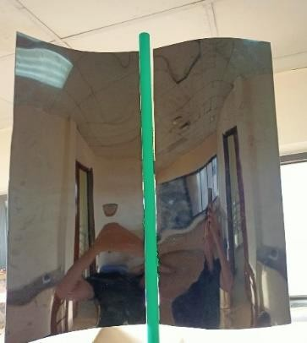
Figure 41: The blades are connected to the main shaft.

Figure 42: Placing the bearing wheels

- After constructing all parts of the prototype, each portion of the prototype was installed properly by using a tube of glue and other methods

Safety precaution

Figure 43: the electric circuit and its component.

While constructing the prototype, the safety precaution was considered a major factor. Whereby, the gloves and lab coat were used to avoid the damage and the negative consequences. Moreover, the whole work was done in the study room and the school labs. Every portion of the prototype was constructed and installed carefully and without using any sharp materials, also goggles were used to protect the eyes from the dust or flying debris. Another crucial aspect is the helmet to protect from falling objects. Also, to achieve high safety precautions, the work was done at low wind speeds to avoid physical injury. Because the construction and installation of the blades were the most difficult and sensitive

step, safety precautions were required. By ensuring balanced installation of blades to prevent vibrations or wobbling. Finally, after following all these steps of safety precautions, the prototype was constructed carefully. In addition to that, the instruments, like globes and lab coats, were used.

Test plan
A test plan is made to ensure that it works properly and meets the design requirements:
- The wind turbine was placed in a windy place to start testing the project.
- The wind speed was measured through an anemometer to determine the relationship between the wind speed and output power.
- Two multimeters were used to measure the output voltage and current intensity.
- The battery was connected to an LED to test if it stores power or not.

Data Collection
While constructing and testing the prototype, there are several tools and instruments were used to calculate the power output and the level of precision and accuracy. At first, multimeter to calculate the power output of the elliptical wind turbine. Secondly, anemometer was used to calculate the wind speed to make a graph for the results of the power output in different areas. Thirdly, the voltameter was used to calculate the total electric charge that passing throughout the generator after the kinetic energy of the wind was converted into mechanical energy. The errors were listed in the negative results, as the direct drive generator was a negative result. Moreover, to measure the power output of the elliptical wind turbine, the multimeter was used. As well as, the measuring tap was used to measure the length of the the blade and the concaveness. The negative results or the errors were concentrated in the gear ratio, due to the uncertainty of the gear ratio the generator didn’t generate the required power output. To reach to the best accuracy the gear ratio was 1:4.

Negative results
While cutting the aluminum plates for the blades, an excess piece was cut, ruining the whole blade. So, we cut another piece. Also, a soldering iron was used to make openings for the blades, but it overheated and melted the inner layer of

the shaft. When the blades were curved, they were curved on different surfaces. So, the curves were not equal. They were curved again on the same surface. Moreover, it was planned to make a direct-drive system, but the RPM was lower than the required, and the torque was more than that. So, A gearbox was made with a ratio of 1:4 to increase the RPM.

Positive results
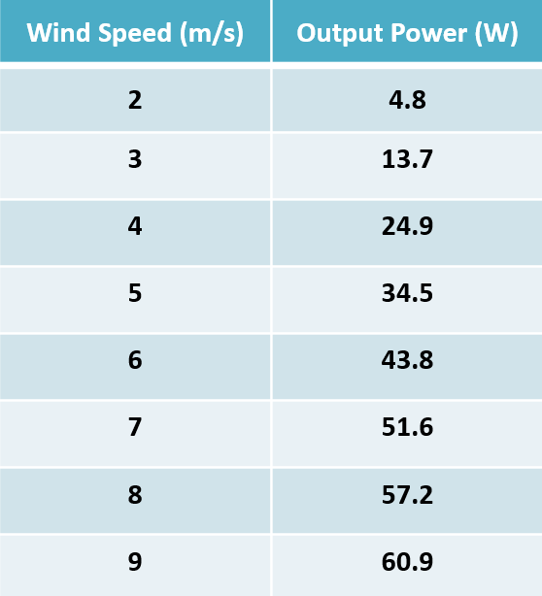
When measured, the power output in a wind speed of 8 m/s was more than 40 W.s after 5 minutes. After dipping the turbine in the graduated tub, the turbine’s volume was found to be 0.043 m^3, under the limit requirements. After testing the battery, the LED lit, indicating that the battery stores electricity properly. Finally, the relation between the wind speed and the output power is put into a table as shown in Table 3.
Table 3: relationship between output power and wind speed

Chapter 4
Evaluation, Reflection, Recommendations and Discussion

Analysis and discussion

Wind power
The wind power formula is the essential law that describes how much kinetic energy from moving wind can be converted into mechanical and electrical power by using wind turbines.

𝟏
𝑷𝒐𝒖𝒕 = 𝟐

× 𝝆 × 𝑨 × 𝑽^{𝟑} × 𝑪𝒑

𝐸𝑞𝑢𝑎𝑡𝑖𝑜𝑛 1: 𝑃𝑜𝑤𝑒𝑟 𝑜𝑢𝑡𝑝𝑢𝑡 𝑟𝑢𝑙𝑒
P_{out} is the electrical power output, ρ is air density, since denser air, like in cold weather or at sea level, has more mass per volume, the wind has more energy. A is the total swept area by the turbine’s blades; V is the wind speed, the most effective factor in the output power. Cp is the power coefficient of the wind turbine, which is. The wind power formula was critical to calculate and determine the dimensions of the wind turbine. Solving the equation for the swept area, the wind speed is measured using an anemometer, and the aspect ratio between the height and diameter is determined. The desired power output was set to the required value. The aspect ratio was chosen. With an average wind speed measured by an anemometer, and a power coefficient set for the elliptical-bladed wind turbine. The swept area was calculated. and then using the determined aspect ratio, the height and the total width are identified.

Drag force
The drag force is a resistive force that acts opposite to the direction of motion of an object moving through a fluid, such as air or liquid. The drag force needed in the elliptical wind turbine to determine aerodynamic performance and overall efficiency. In a vertical wind turbine, the drag force is the force exerted by the wind as it interacts with the surfaces of the rotating blades. This force acts in the direction opposite the relative motion between the wind and the blade surface. In the elliptical wind turbine, the blades follow a curved path and continuously change orientation relative to the incoming wind. There is a crucial aspect, which is the effect of the drag becoming dynamic and varying with the blade’s angular position, and the drag introduces resistance that reduces the net power output. The drag force F_{d} acting on a blade can be described by using the
drag equation: Fd = 𝟏 Cd ρ A v²
𝟐
Equation 2: The equation of the drag force

Where C_{d} is the drag coefficient, F_{d} is the instantons drag force, A is the effective surface area of the blade that is facing the wind (cross sectional area), considering as a reference area, v is the speed of the air relative to the air(fluid), ρ density of the air.

Kinetic energy conversion (Generator mechanism)
Kinetic conversion in the elliptical wind turbine refers to the process of transforming the kinetic energy of wind into mechanical energy, and then into electrical energy by using the generator. This formula was used to calculate the kinetic energy of wind,

Ek = 𝟏
𝟐
m.v

Equation 3 is used to calculate the kinetic energy of wind,
where E_{k} equals kinetic energy in joules, m is the mass of the moving air, and V is the velocity of the air. An elliptical wind turbine is scaled up to power per second, considering how much wind is passing through the turbine by using this formula, P wind=1/2ρAv3. After the generator converted the mechanical energy into electrical energy. This formula,
Pelec= η. Pmech
Equation 4 is used to calculate the electrical power from the generator,
used to calculate the electric power output from the generator, where P_{elec} is the electrical power output in watts, P_{mech} is the mechanical power input from the turbine, and η is the efficiency of the generator system. There is another formula to calculate the mechanical power from the shaft:
Pmech= t ⋅ ω
Equation 5 is used to calculate the mechanical power from the shaft,
where t refers to the torque. ω\omega = angular velocity (rad/s). This formula was used to calculate the mechanical power transmitted from the turbine(gearbox) to the generator. The gearbox was used to convert low wind speed and high torque motion into high wind speed and lower torque.

Gearbox
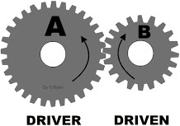
A gearbox or a transmission is a mechanical component mainly used to transfer mechanical energy. It is also used in mechanical systems such as wind turbines to control the speed (RPM) and the torque of the mechanical system. During testing of the project, it was found that the
Figure 44: Illustration of a driver and driven gear

RPM of the rotor is lower than the required RPM for the generation. So, it was critical to use a gearbox with a specific gear ratio to increase the RPM. The RPM of the driven gear is calculated by using the formula:

RPM of the driven gear = RPM of the driver gear× ^{𝟏} ,
𝒈𝒆𝒂𝒓 𝒓𝒂𝒕𝒊𝒐
Equation 6: Driven gear RPM rule
the gear ratio must be lower than 1 to increase the RPM. The gear ratio is given by the formula:
Gear ratio = 𝒏𝒖𝒎𝒃𝒆𝒓 𝒐𝒇 𝒕𝒆𝒆𝒕𝒉 𝒐𝒇 𝒕𝒉𝒆 𝒅𝒓𝒊𝒗𝒆𝒏 𝒈𝒆𝒂𝒓
𝒏𝒖𝒎𝒃𝒆𝒓 𝒐𝒇 𝒕𝒆𝒆𝒕𝒉 𝒐𝒇 𝒕𝒉𝒆 𝒅𝒓𝒊𝒗𝒆𝒓 𝒈𝒆𝒂𝒕
Equation 7: Gear ratio rule
Therefore, the driven gear must be smaller than the driver gear. One of the impacts of the gearbox is the inverse relation between the torque and RPM. That means when the RPM increases, the torque decreases, and vice versa. The torque of the driven gear is given by the formula:

torque of the driven gear = torque of the driver gear * gear ratio
Equation 8: Driven gear torque rule

Conclusions
The Air Flair project, if constructed will partially, if not fully fix many of Egypt’s grand challenges such as “Improve the use of alternative energies”, “Address & reduce pollution in air, water and soil”, “Work to eradicate public health issues” As it fixes the power shortage issue, providing electricity to health sectors, filtration facilities and infrastructure. This will also improve the use of alternative energy sources.
The prototype generates 2 watts per 5 minutes, which is equivalent to 800 joules per 5 minutes, exceeding the design requirements by 760 joules. In addition to that, it has a height of 80 cm, a width of 42 cm, and a volume of 1.08 m^{3,} which is 4.92 less than the design requirement. Meaning the prototype meets all design requirements.
The project also reduces the dependence on fossil fuels, meaning that in the long term, renewable energy will replace polluting energy sources, and Egypt will be fully dependent on clean energy such as wind power.

Recommendations

Data analysis system:
It’s recommended to add a data analysis system that is useful in tracking progress and detecting any possible errors. It’s composed of multiple sensors, like a motion sensor to detect RPM, an anemometer to measure wind speed for any possible problems, and a wattmeter for detecting the power output per second. Then, a microprocessor is linked with the sensor and a coded app, making it able to check any status anytime. It will be very helpful for detecting errors, but we cannot apply it due to the extreme price of the sensors.

Lightweight composite material:
The turbine’s blades should be as lightweight and smooth as possible for the best performance, which is why it’s recommended to use carbon fiber as the blades’ material. It’s a composite material that makes it light while maintaining its high rigidity and strength, and has a longer lifespan. And the smooth surface and the shape stability significantly improve the aerodynamic efficiency. But despite all those benefits, the high cost makes it hard for us to use it.

Automatic braking system (speed limiter)
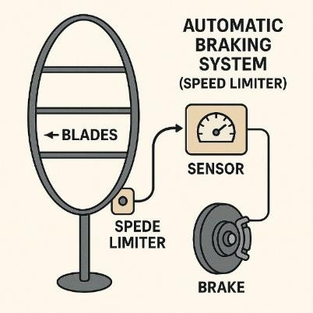
It is recommended to add an automatic brake system, as illustrated in Figure 45, to prevent damage in high wind speeds. It works by slowing down or stopping when wind speeds are dangerously high. As a result, it protects the turbines from spinning too fast, which can cause mechanical failure or structural damage. It will be so helpful in the residential areas and
the regions where the wind speed is not constant. It

works as the rotor moves faster; the rotational motion
Figure 45: An illustration of the
automatic braking system

creates a centrifugal force. In a centrifugal braking system, there are small arms or pads, like little metal pieces with weights on them, attached near the spinning shaft. When the turbine rotates normally, they stay close to the center, but when it spins too fast, the centrifugal force increases. As a result, it pushes those arms or pads outward, and as they move outward, they press against a braking surface. This creates a friction that slows down the turbine. It wasn’t used on the capstone prototype because of the high costs and unavailable materials, whereby quality braking components (springs, arms, sensors, resistors) are expensive. Moreover, precision machine or sensor programming was not accessible in the school lab.

Recommendations to Future Teams
In our capstone project, we stopped after constructing the prototype and writing the portfolio as well as the other chapters in the capstone project. To be a successful team, you should make several modifications to your project by deepening your understanding of scientific concepts. For instance, you should deal with subjects you learn differently, such as physics, and you should acquire numerous benefits from physics, such as measurement tools, data analysis, and others. Moreover, you can use the 3d programs to make a 3d design for your prototype. This can help you simulate the real-life application. Our solution is an elliptical wind turbine. To further illustrate, we used a direct drive generator to reduce the mechanical wear, increase efficiency, and reduce the water loss. All these disadvantages, because the permanent magnet generator converts the mechanical energy into electrical energy without using gears. I suppose making strong scientific research to provide more illustrations. On the other hand, academic writing skills are a crucial part of the capstone project. From my perspective, academic writing is a major aspect of the portfolio that can help you enhance the quality of the tasks in the portfolio. In our capstone project, we were interested in improving our writing to give the evaluator a wonderful view of our poster and portfolio. Nevertheless, as I mentioned, the benefits from learning outcomes weren’t a lot. Therefore, I advise you to deepen your understanding of these learning outcomes. This will help you in your project

Project’s benefits
We acquired several experts from working in the capstone project, we also enhanced numerous skills such as writing in academic English. We will divide the positive impacts into 3 main categories.
Firstly, the social impacts we gained from working in the capstone project can be mentioned as teamwork, dealing with different people, and confidence. For instance, after finishing the capstone project, I became able to comprehend complex matters, whereby I can deal with many people in the best way as well as possible, due to buying the materials needed to construct the prototype.
Secondly, due to the scientific research we have done, we have acquired several benefits and positive impacts. To further illustrate, I searched for the drag force to write it as a concept in the analysis of the poster. Because of that and other research I have done. I became able to deepen my understanding of any scientific concept I wanted to learn.

Thirdly, we have made several 3d designs for our prototype to simulate it properly. Because of that, I liked the cs club in our school, and I decided to participate in it to acquire more experience in computer science and programming.
Finally, working in the capstone project has numerous positive effects on all team members. However, you should make a huge effort to achieve these requirements.

Learning outcomes
Table 4: Learning outcomes

Subject | Concept | Subject | Concept
(CH.1.09) | Malleability was used as a factor of the material needed to construct the blades  (Aluminum) | (PH.1.09) | The concept of general properties of fluids was used to study the characteristics of fluids, such as viscosity and pressure, and to identify  the characteristics of the air.
(MA.1.07) | The concept of the parabola was used to simulate the concavity of the blades and  calculate the dimensions. | (ME.1.07) | The concept of friction was used to study the friction between gears. This friction affects the torque and the gear ratio.
(ES.1.09) | The concept of electrical energy was used to study the characteristics of electrical energy. | (ME.1.09) | The concept of centripetal force was used to determine how the force affects the blades in different wind speeds.
(PH.1.11) | The concept of energy graphs was used to draw the graphs of mechanical, kinetic, and electrical energy | (ES.1.08) | The concept of modern electronics technologies was used to construct the electric circuit and study its components.

(ES.1.10) | The concept of the precision of measurement of the anemometer and calculations of wind power was used to measure the  wind speed. | (CS.1.07) | The concept of declare and use primitive data types was used to make the graphs and table of results. Also was needed in the data analysis.

List of sources in APA format

- Types of fuel cells. (n.d.). Energy.gov. https://www.energy.gov/eere/fuelcells/types-fuel-cells
- Nogueira, J. A., & Varela, H. (2020b). Direct Liquid Fuel Cells—The influence of temperature and dynamic instabilities. Energy & Fuels, 34(10), 12995–13009. https://doi.org/10.1021/acs.energyfuels.0c02491
- What are biofuels? Types and main advantages | Repsol. (2024, October 18). REPSOL. https://www.repsol.com/en/technology-and-digitalization/technology-lab/emissions-
reduction/biofuels/index.cshtml#:~:text=Biofuels%20are%20fuels%20derived%20fro m,part%20of%20our%20daily%20lives
- China Savonius wind Turbine, Savonius wind turbine wholesale, manufacturers, price | Made-in-China.com. (n.d.).
https://www.made-in-china.com/products-search/hot-china-
products/Savonius_Wind_Turbine.html

- World Bank Climate Change Knowledge Portal. (n.d.). https://climateknowledgeportal.worldbank.org/country/egypt/climate-data-historical

- Egypt Air Quality Index (AQI) and Air Pollution information | IQAir. (n.d.). https://www.iqair.com/egypt?srsltid=AfmBOoqDTOTEBc2qal9WMeN8vGU-
bBGpDcMftbU95SEcOhWwqnPxeKGx

- Alternative Policy Solutions | The Social Impact of Air Pollution in Egypt: The Contradictions of Environmental Policy in Egypt. (n.d.-b). https://aps.aucegypt.edu/en/articles/767/the-social-impact-of-air-pollution-in-egypt-
the-contradictions-of-environmental-policy-in-egypt

- The world’s largest offshore wind farm - Dogger Bank Wind Farm. (2025, February 19).

Dogger Bank Wind Farm. https://doggerbank.com/
- Dogger Bank Offshore Wind Farm | SSE Renewables. (n.d.). https://www.sserenewables.com/offshore-wind/projects/dogger-bank/
- World’s largest offshore wind farm Dogger Bank produces power for the first time. (2023, October 19). Equinor.
https://www.equinor.com/news/202310-dogger-bank

- Stanford Magnets. (n.d.). Permanent Magnet Generator: An Overview. https://www.stanfordmagnets.com/permanent-magnet-generator-an-overview.html
- Permanent Magnet Generator | MECC Alte. (n.d.). https://www.meccalte.com/en/products/alternators/zanardi-products/pmg
- Winder Power. (2025, April 16). Permanent Magnet Generators - Winder Power. https://www.winderpower.co.uk/products/permanent-magnet-generators/
- Roser, M., Ochmann, S., Behrens, H., Ritchie, H., & Dadonaite, B. (2018, October 1).

Eradication of diseases. Our World in Data. https://ourworldindata.org/eradication-of-diseases

- Egypt. (n.d.). Datadot. https://data.who.int/countries/818
- Arab Development Portal. (n.d.). https://data.unescwa.org/Datacatalog/Dataset/un-
agencies%2Fwho%2FHospital%20beds%20per%2010%20000%20population%20_0 4042023065634
- Ufheil-Somers, A. (2016, November 19). Facts and figures on Cairo - MERIP. MERIP. https://merip.org/1997/03/facts-and-figures-on-cairo/
- Amnesty International. (2024, August 15). Egypt: New law threatens to reduce access to healthcare for millions.
https://www.amnesty.org/en/latest/news/2024/07/egypt-new-law-threatens-to-reduce-

access-to-healthcare-for-millions/

- Emhj. (n.d.). Knowledge, practices and attitudes of physicians towards evidencebased medicine in Egypt. World Health Organization - Regional Office for the Eastern Mediterranean.
https://www.emro.who.int/emhj-volume-25-2019/volume-25-issue-2/knowledge-
practices-and-attitudes-of-physicians-towards-evidencebased-medicine-in-egypt.html
- World Bank Open Data. (n.d.). World Bank Open Data. https://data.worldbank.org/indicator/SP.POP.GROW?end=2023&locations=EG&start
=2000&view=chart

- Washington, A. C., DC. (2021, April 21). Is Egypt’s population growth a blessing or a curse? Arab Center Washington DC.
https://arabcenterdc.org/resource/is-egypts-population-growth-a-blessing-or-a-curse

- SIE. (n.d.). SiE.

https://study-in-egypt.gov.eg/living-in-egypt/23?name=egyptian-people

- Arief, O. M., & Ahmed, D. A. (2023). Goods and Services Provided by Native Plants in Nile Delta, Egypt: in the Viewpoint of Conservation. Egyptian Journal of Botany, 0(0), 0.
https://doi.org/10.21608/ejbo.2023.200845.2282

- CDC in Egypt. (2024, May 15). Global Health. https://www.cdc.gov/global-health/countries/egypt.html
- About chronic diseases. (2024, October 4). Chronic Disease. https://www.cdc.gov/chronic-disease/about/index.html
- World Health Organization: WHO. (2024, August 7). The top 10 causes of death. https://www.who.int/news-room/fact-sheets/detail/the-top-10-causes-of-death
- Cairo and air pollution - Clean Air Fund. (2023, November 22). Clean Air Fund. https://www.cleanairfund.org/clean-air-africas-cities/cairo/
- Egypt -Electricity and Renewable Energy. (2022b, August 8). International Trade Administration | Trade.gov.
https://www.trade.gov/country-commercial-guides/egypt-electricity-and-renewable-

energy
- Ember. (2025, April 11). EGYPT | Ember.
https://ember-energy.org/countries-and-regions/egypt/
- CurrentElectricity Tariff. (n.d.). https://egyptera.org/en/TarrifAug2024.aspx
- Climatescope 2024 | Egypt. (n.d.-b). https://www.global-climatescope.org/markets/egypt
- World Bank Group. (2024, October 29). Oversupply could mute effects of wider Middle- East conflict on oil prices. World Bank.

https://www.worldbank.org/en/news/press-release/2024/10/29/commodity-markets-

outlook-october-2024-press-release

- Natural gas Pricing – Gas Regulatory Authority. (n.d.). https://www.gasreg.org.eg/natural-gas-pricing/
- Egypt | Department of Economic and Social Affairs. (n.d.). https://sdgs.un.org/basic-page/egypt-34124
- Country Report on Egyptian Agriculture and Summary of IPI experiments. (2013, March 1).
https://www.ipipotash.org/publications/eifc-

269#:~:text=Egypt%20occupies%20a%20total%20area,most%20fertile%20soils%20i n%20Egypt.
- International Prices of Crude Oil (Indian Basket), Petrol and Diesel | Petroleum Planning & Analysis Cell | Government of India. (n.d.). https://ppac.gov.in/prices/international-prices-of-crude-oil
- BUILDING BIG: Databank: Aswan High Dam. (n.d.). https://www.pbs.org/wgbh/buildingbig/wonder/structure/aswan_high.html
- The High Dam - Aswan | The Arab Contractors. (n.d.). https://www.arabcont.com/english/project-144
- Memphis Tours. (n.d.). The High Dam in Aswan egypt. https://www.memphistours.co.uk/Egypt/Egypt-Travel-Guide/Aswan-
Attractions/wiki/The-High-Dam-in-Aswan

- How a wind turbine Works - text version. (n.d.). Energy.gov. https://www.energy.gov/eere/wind/how-wind-turbine-works-text-version
- Statista. (2024, June 30). Number of graduates of TVET in Egypt 2021/2022, by specialty and gender.

https://www.statista.com/statistics/1252852/number-of-technical-vocational-training-

graduates-by-specialty-and-gender-in- egypt/#:~:text=Number%20of%20graduates%20of%20TVET,2022%2C%20by%20s pecialty%20and%20gender&text=The%20total%20number%20of%20graduates,2022
%20amounted%20to%20around%20640%2C000

- Statista. (2024b, November 22). Global unemployment rate 2004-2023. https://www.statista.com/statistics/279777/global-unemployment-rate/
- Statista. (2024c, November 22). Unemployment rate in Egypt 2023. https://www.statista.com/statistics/377343/unemployment-rate-in-egypt/
- TU9 Alliance. (n.d.).

https://www.tu9.de/en/

- Admin. (2024, July 1). Faraday’s Laws of Electromagnetic Induction. BYJUS. https://byjus.com/physics/faradays-law/

